Eltham Town Centre Design Guidelines

#### PART B - Transport Hub (Precinct 3) Design Guidelines

Final - February 2014

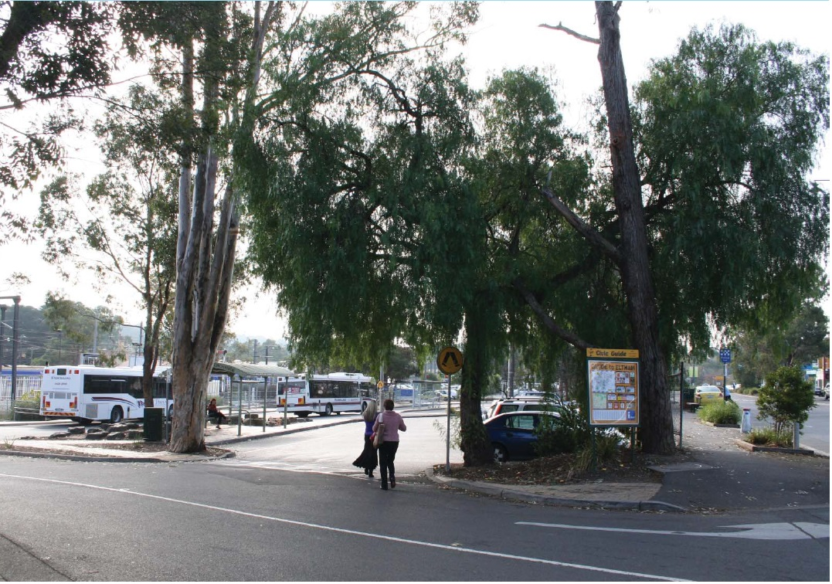

#### PART B – Transport Hub Design Guidelines

##### 1.1 The Transport Hub

The Transport Precinct is generally bounded by Youth Road to the west, Diamond Street to the north and Main Road to the east.

These Design Guidelines are intended to be used by anyone who is interested or involved in the planning and development process (landowners, designers, developers, community, Council etc) to better understand how to suitably respond to local planning policies and design controls associated with the Eltham Town Centre.

A Design and Development Overlay (DDO6) applies to land within the Eltham Town Centre, which sets regulations and development expectations to realise the preferred character of the area. Use these design guideline documents to assist in the design phases for all new development within the Eltham Town Centre precincts.

The Eltham Town Centre Design Guidelines have been separated into 2 parts and include the following:

**Part A: The General Design Guidelines (applicable to all land within the Eltham Town Centre Precincts)**

The purpose of the General Eltham Town Centre Design Guidelines is to provide basic design directions for all development formats within the Eltham Town Centre boundary including new commercial, residential and community developments.

**Part B: Precinct Design Guidelines (applicable to land located within the specified precinct boundary)**

The purpose of the Precinct Design Guidelines is to provide specific guidance that supports the preferred character for the each precinct.

Note: All new development must have regard to both documents, PART A & B respectively.

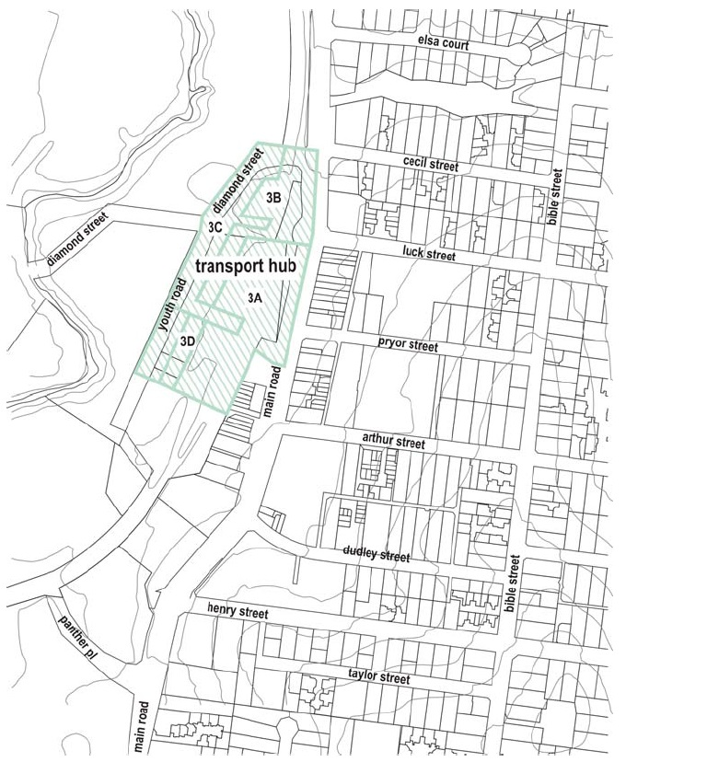

##### 1.2 The Preferred Character

The preferred character for the Transport Precinct includes:

* This area will provide additional opportunities for medium density housing and mixed use developments that are designed to maintain the modest scale of Eltham and improve passive surveillance of adjoining public spaces.
* The strong presence of native canopy trees will be maintained through careful siting and design of development.

##### 1.3 Precinct Design Objectives

* To encourage the creation of active edges fronting Main Road and the railway area that provides safe and convenient access between community facilities in the south and public transport facilities.
* To encourage medium density housing.
* To ensure that future development maintains and enhances the functionality of the precinct as a commuter hub.

#### PART B – Site Design Guidelines

##### SD02: Vegetation (cont.)

**Design Guidelines and Directions:**

Development should incorporate existing large native trees where possible. Clustering of development thus creating courtyards or setbacks for landscaping is encouraged.

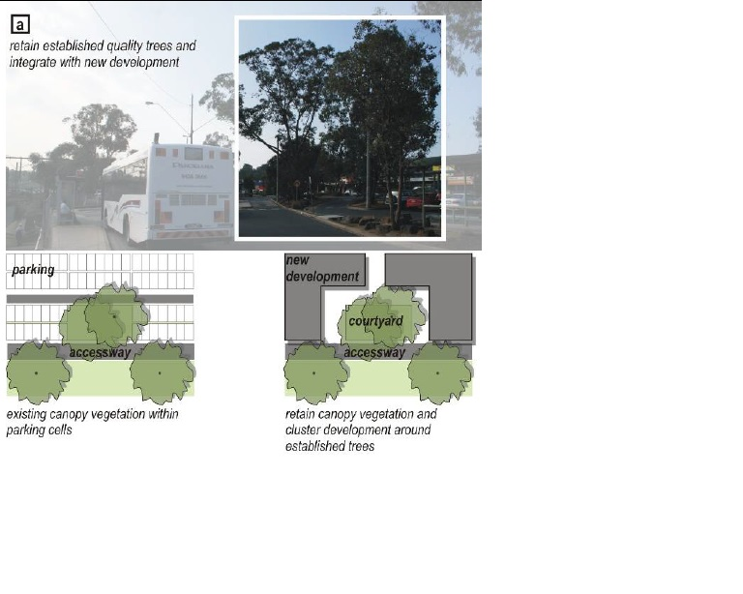

##### SD04: Streetscape Pattern (cont.)

**Design Guidelines and Directions:**

Development with a frontage to Main Road should provide a minimum 5.5metre front setback at ground level.

Development fronting Youth Road and Diamond Street should provide landscaped front building setback of a minimum of 5.5metres from the roadside kerbs at ground level.

New developments should incorporate feature architectural or landscape features at exposed locations as viewed from Main Road (north) and axial views available from east – west running streets, namely Luck Street, Pryor Street and Diamond Street.

Development fronting Main Road and the east side of the public transport interchange should provide active uses and frontages at ground level.

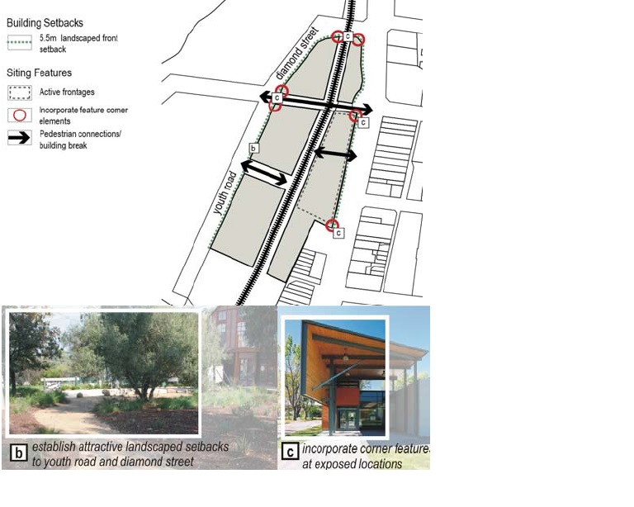

##### SD05: Functionality (cont.)

**Design Guidelines and Directions:**

Level changes should be accommodated within buildings so that minimal changes of level occur in the public domain.

Incorporate public access ways to improve east-west links between Main Road, Eltham Station and sporting facilities.

Building adjacent to the railways should incorporate noise abatements measures to reduce amenity impacts.

#### PART B – Building Design Guidelines

##### BD01: Building Height and Form (cont)

**Design Guidelines and Directions:**

Overall building height in any part of the precinct must not exceed 5 storeys (17.5 metres).

The development in any part of the precinct should provide a minimum of 5.5m street setback from roadside kerbs.

Building height on sites within Sub-precinct 3A frontage should not exceed a maximum of 5 storeys (17.5 metres) and the third storey should be recessed a minimum of 3 metres from the first storey wall on any street frontage. The final storey should be restricted to roof space only.

Building heights within Sub-precincts 3B and 3D should not exceed a maximum of 4 storeys (14.0m) and the third storey should be setback a minimum of 3 metres from the first floor frontage. The fourth storey development is only permitted to be in the roof space.

Building height on sites within Sub-precinct 3C should not exceed a maximum of 3 storeys (10.5 metres) and the third storey must be recessed a minimum of three metres from the first storey wall on any street frontage. Development fronting Youth Road and Diamond Street must have landscaped front building setbacks.

Developments to the western side of the railway line should provide a transition with community uses along Diamond Street and Youth Road.

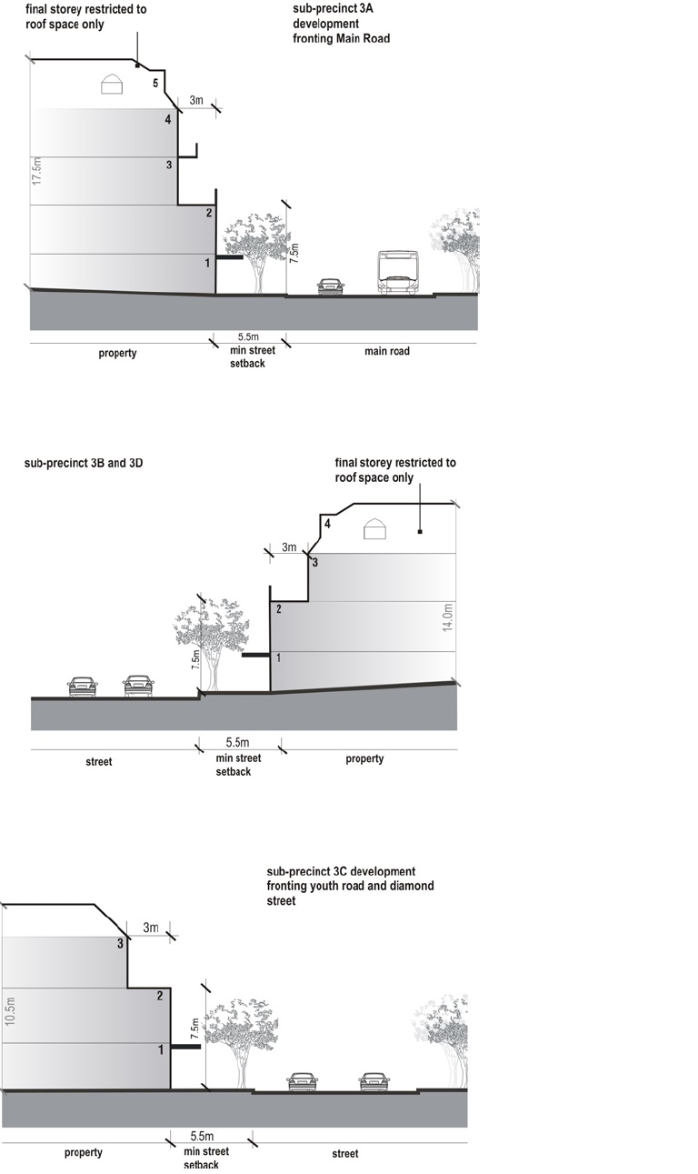

##### BD02: Building Style and Façade Composition (cont)

**Design Guidelines and Directions:**

New development fronting Main Road should provide articulate facades that relate with the fine grain shopping strip opposite. Incorporate vertical features of similar proportions with the streetscape.

Developments to the western side of the railway line should reflect a transition with existing community developments along Diamond Street and parklands opposite. Design buildings to offer a domestic appearance.

The design of the buildings backing onto the railway line and the train station car parks should present interesting façade treatments.

The design and presentation of buildings backing onto the railway line and train station car park should;

* present as an interesting façade through varying textures and finishes
* allow for passive surveillance to occur through locating active areas/ glazing towards the rear
* reduce broad areas of a single surface finish to deter graffiti
* incorporate vegetative or architectural screening devices
* ensure design measures are in place to reduce noise impacts

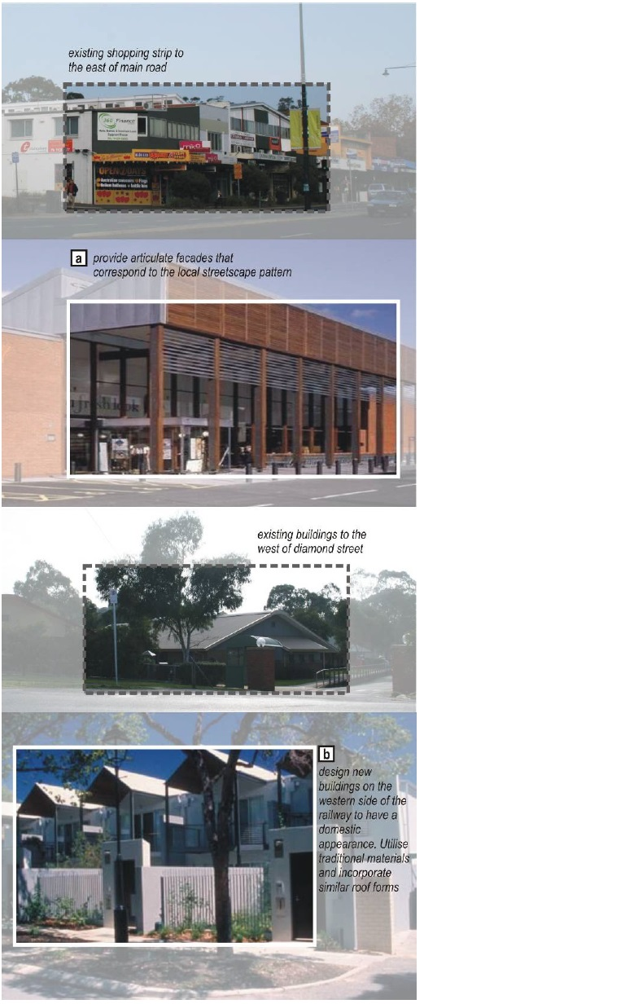

#### PART B – Building Context Guidelines

##### BC01: Access and Parking (cont)

**Design Guidelines and Directions:**

New development should utilise existing road infrastructure and avoid the creation of unnecessary vehicle access ways.

Support a reduction in car parking requirements for small residential units in close proximity to the station.

Medium density housing/ mix use development car parking should be concealed within the building or located underground. Avoid excessive use and reliance on car stackers.

Service areas and car parking should be concealed and located at the rear of buildings, or serviced by laneways. Incorporate screening devices to enhance the presentation of ‘back of house’ activities and service areas.

Car parking entryways should be located to the edge of sites, and clustered with other car parking entries.

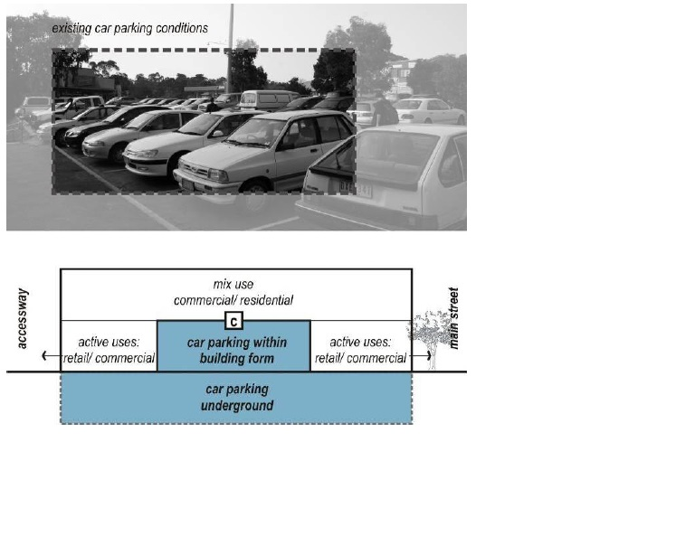

##### BC02: Boundary Treatments - Landscape and Fencing (cont)

**Design Guidelines and Directions:**

Excessive use of roller doors is strongly discouraged. Incorporate high quality materials such as perforated sheeting and timber/ metal panels

Medium density development should not locate private open spaces and screen fencing to face the street.

New development should incorporate acoustic treatments responding to the railway environment to minimise adverse amenity impacts.

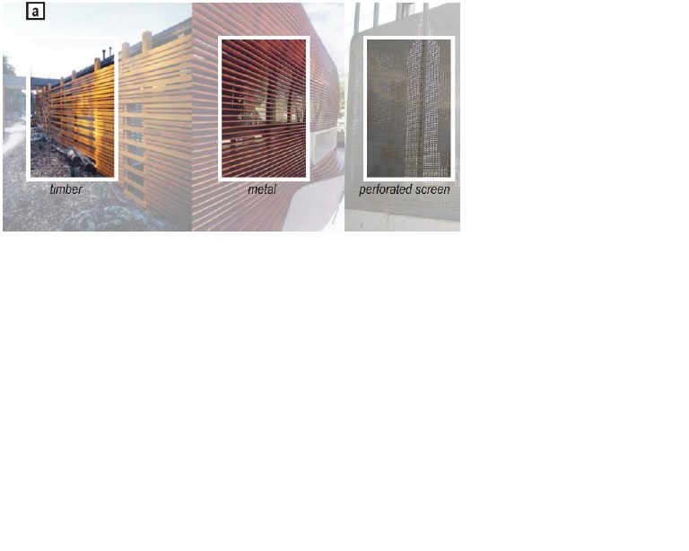

#### PART B – Public Domain Guidelines

##### PD01: Access, Footpaths and Parking (cont)

**Design Guidelines and Directions:**

Accessways proximate to the Eltham Train Station should be designed to foster a low speed environment and reduce pedestrian conflict points.

Protect and enhance the functionality of the precinct as a commuter hub by maintaining convenient and safe access to public transport services.

Footpaths accessing key public transport facilities (Train station and bus interchange) should be direct and convenient. Pathways should be generous in width (in the order of 2.5 – 3 metres) to cater for high volumes of pedestrian traffic.

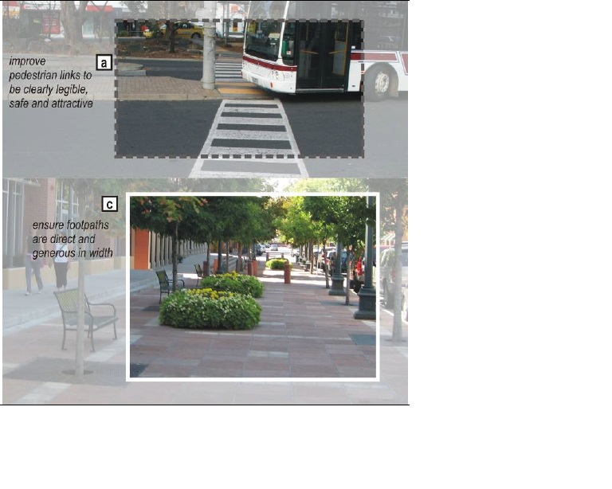

##### PD02: Landscape – Soft and Hard (cont)

**Design Guidelines and Directions:**

Ensure central median landscape planting is regularly maintained to ensure clear sightlines to pedestrian crossings and street lights.

Plant indigenous trees throughout.

##### PD03: Street Furniture, Lighting and Signage (cont)

**Design Guidelines and Directions:**

Encourage co-location of street furniture so that it may have dual functions.

Upgrade bus interchange to include appropriate shelters, seating and street furniture. Such facilities should not interrupt pedestrian traffic flow and where possible integrate with new buildings.

Locate bicycle parking to be close to the station and in highly visible locations.

