Eltham Town Centre Design Guidelines

#### PART B - Civic Centre (Precinct 4) Design Guidelines

Final - February 2014

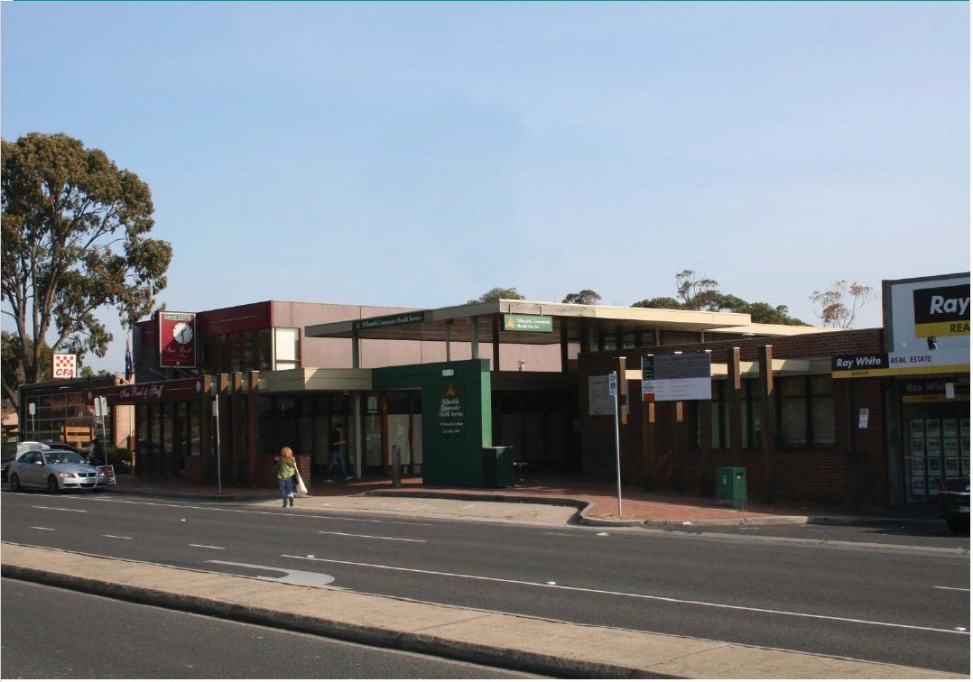

#### PART B – Civic Centre Design Guidelines

##### 1.1 The Civic Centre Precinct

The Civic Centre Precinct is generally bounded by Youth Road to the west, Diamond Street to the north and Main Road to the east.

These Design Guidelines are intended to be used by anyone who is interested or involved in the planning and development process (landowners, designers, developers, community, Council etc) to better understand how to suitably respond to local planning policies and design controls associated with the Eltham Town Centre.

A Design and Development Overlay (DDO6) applies to land within the Eltham Town Centre, which sets regulations and development expectations to realise the preferred character of the area. Use these design guideline documents to assist in the design phases for all new development within the Eltham Town Centre precincts.

The Eltham Town Centre Design Guidelines have been separated into 2 parts and include the following:

**Part A: The General Design Guidelines (applicable to all land within the Eltham Town Centre Precincts)**

The purpose of the General Eltham Town Centre Design Guidelines is to provide basic design directions for all development formats within the Eltham Town Centre boundary including new commercial, residential and community developments.

**Part B: Precinct Design Guidelines (applicable to land located within the specified precinct boundary)**

The purpose of the Precinct Design Guidelines is to provide specific guidance that supports the preferred character for the each precinct.

Note: All new development must have regard to both documents, PART A & B respectively.

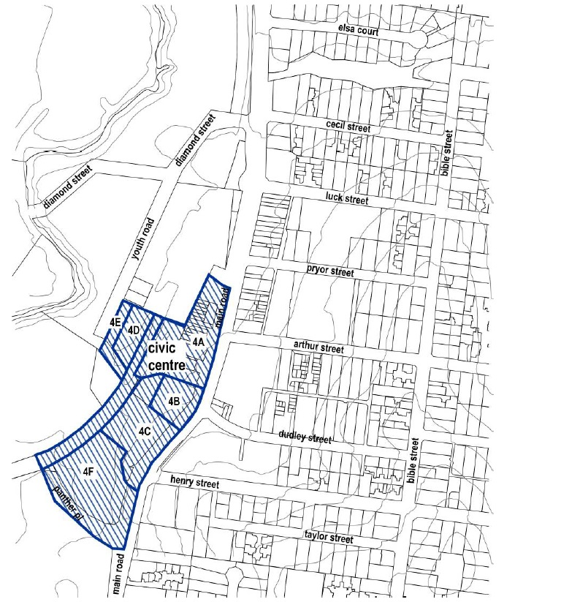

##### 1.2 The Preferred Character

The preferred character for the Civic Centre Precinct includes:

This area will be the iconic heart of Eltham providing a range of community, residential and professional services with buildings and landscaping reflecting the Eltham design theme.

##### 1.3 Precinct Design Objectives

* To encourage the creation of active edges fronting Main Road, encouraging temporary use of the footpath by adjoining uses that ‘spill out’ onto the street.
* To encourage an activated pedestrian environment to the rear of Main Road buildings to provide safe and convenient access between the community facilities to the south and the public transport facilities.

#### PART B – Site Design Guidelines

##### SD04: Streetscape Pattern (cont.)

**Design Guidelines and Directions:**

Development fronting Main Road should provide a minimum front setback of 5.5 metres at ground level from the roadside kerb

Development on the former Eltham Shire Office (895 Main Road) site should provide generous landscaped setbacks from the street and retain established vegetation including the heritage nominated Italian Cypress trees.

Development fronting to Main Road and the railway line should provide active uses at ground level and safe and convenient access to the adjacent public transport facilities.

Development fronting Library Place and the car park should include active frontages.

Thick and robust building elements such as colonnades should be incorporated into the design of the new building.

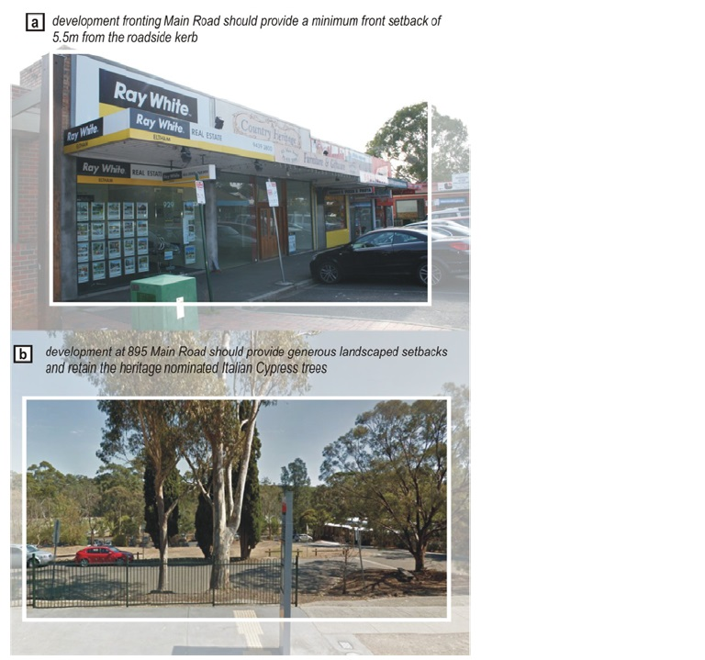

##### SD05: Functionality (cont.)

**Design Guidelines and Directions:**

New development backing onto the existing railway car park should provide opportunities to ‘open’ out and allow internal pedestrian connections through to Main Road.

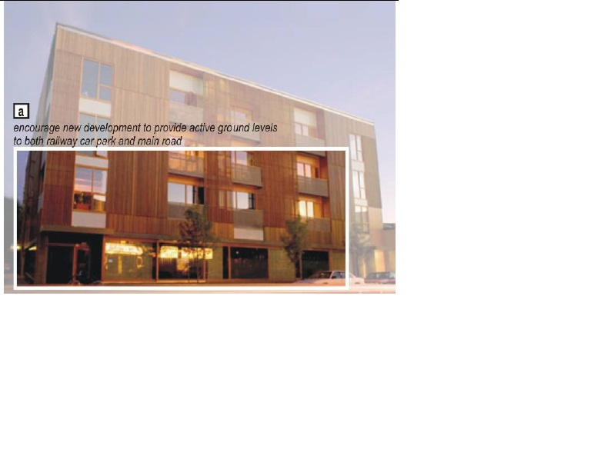

#### PART B – Building Design Guidelines

##### BD01: Building Height and Form (cont)

**Design Guidelines and Directions:**

Overall building height in any part of the precinct must not exceed 5 storeys (17.5 metres).

Any development within the Civic Centre precinct should provide a minimum front setback of 5.5 metres from the roadside kerb.

Building height on sites with frontage to Main Road should not exceed a maximum of 5 storeys (17.5 metres) and the third storey must be recessed a minimum of 3 metres from the first storey wall on any street frontage.

Building height with frontage to Main Road and identified in Sub precinct 4B should not exceed 14.0m and a third storey and above should be setback a minimum of 3 metres from the first floor frontage.

Development with a frontage to railway line and identified in Sub precinct 4C and 4D should not exceed 14.0m with a 4th storey to be located in the roof space. A third storey should be setback a minimum of 3 metres from the first floor frontage.

Building height with frontage to Panther Place and parklands to the north which are identified within Sub precinct 4E and 4F should not exceed 10.5m. The third storey should be recessed of a minimum of 3m from the first floor frontage.

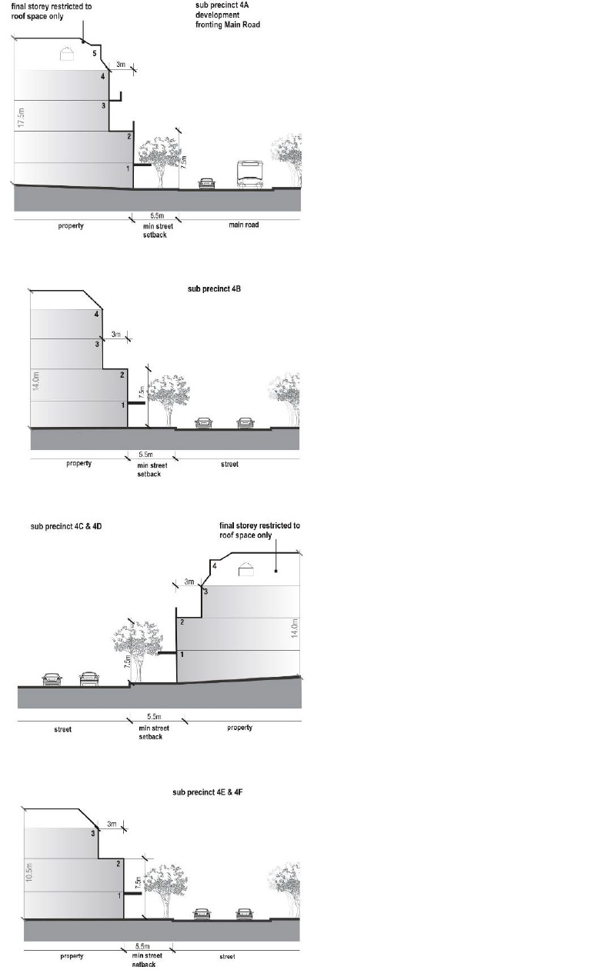

##### BD02: Building Style and Façade Composition (cont)

**Design Guidelines & Directions:**

Main pedestrian entrances should be clearly legible from the street and demarcated with strong architectural features. Where canopy awnings prevail, new developments should seek to continue the prevailing profile and height with adjoining structures.

The design and presentation of buildings backing onto the railway line and train station car park should;

* present as an interesting façade through varying textures and finishes
* allow for passive surveillance to occur through locating active areas/ glazing towards the rear
* reduce broad areas of a single surface finish to deter graffiti
* incorporate vegetative or architectural screening devices
* ensure design measures are in place to reduce noise impacts

Thick and robust buildings elements such as colonnades are common within the precinct. Incorporate such elements to blend in with existing built form character of the area.

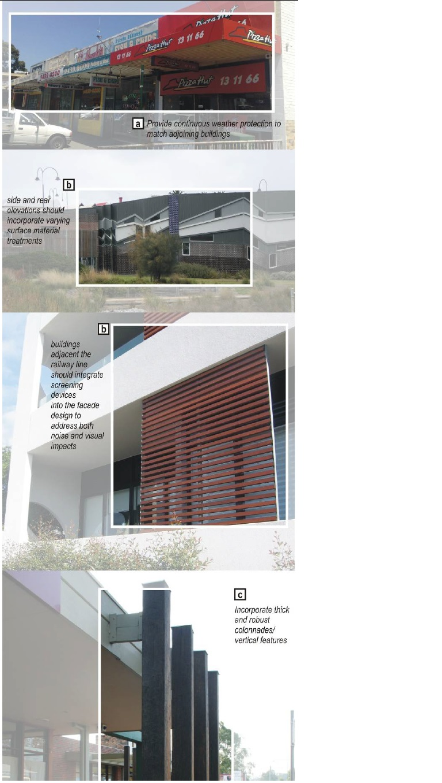

#### PART B – Building Context Guidelines

##### BC01: Access and Parking (cont)

**Design Guidelines and Directions:**

Ensure vehicle entry points of new developments do not adversely impact the function of Main Road.

Ensure safe and convenient east – west vehicle and pedestrian connections to the existing railway car park is maintained.

Service areas and car parking should be concealed and located at the rear of buildings, or serviced by laneways. Incorporate screening devices to enhance the presentation of ‘back of house’ activities and service areas.

##### BC02: Boundary Treatments - Landscape & Fencing (cont)

**Design Guidelines and Directions:**

Excessive use of roller doors is strongly discouraged. Incorporate high quality materials such as perforated sheeting and timber/ metal panels

Medium density development should not locate private open spaces and screen fencing to face the street.

New development should incorporate acoustic treatment responding to the railway environment to minimise adverse amenity impacts.

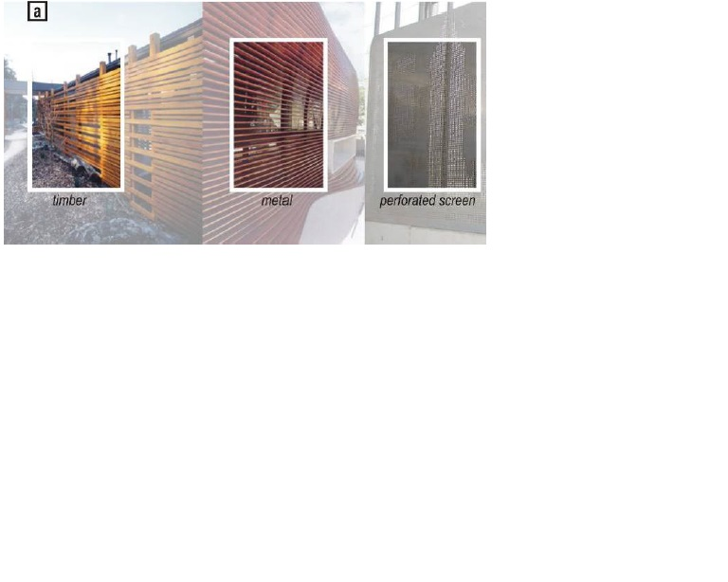

#### PART B – Public Domain Guidelines

##### PD01: Access, Footpaths and Parking (cont)

**Design Guidelines and Directions:**

Improve east-west pedestrian access between the Commercial Core (Precinct 1) and this precinct. Investigate additional pedestrian crossings across Main Road.

Retain commuter car parking along the railway line.

Establish dedicated pedestrian footpath along the railway line and within commuter parking. Such footpaths should be a minimum of 1.5metres wide.

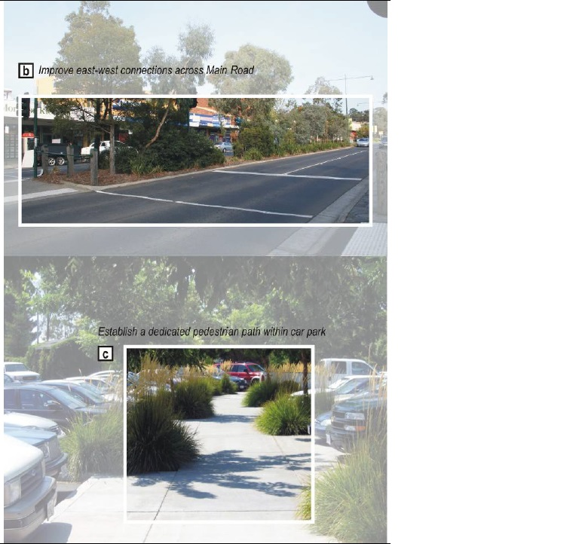

##### PD02: Landscape – Soft and Hard (cont)

**Design Guidelines and Directions:**

Locate public artwork within the Eltham Square or on the threshold of community buildings.

Plant indigenous trees throughout.

