Eltham Town Centre Design Guidelines

#### PART A - General Design Guidelines

Final | February 2014

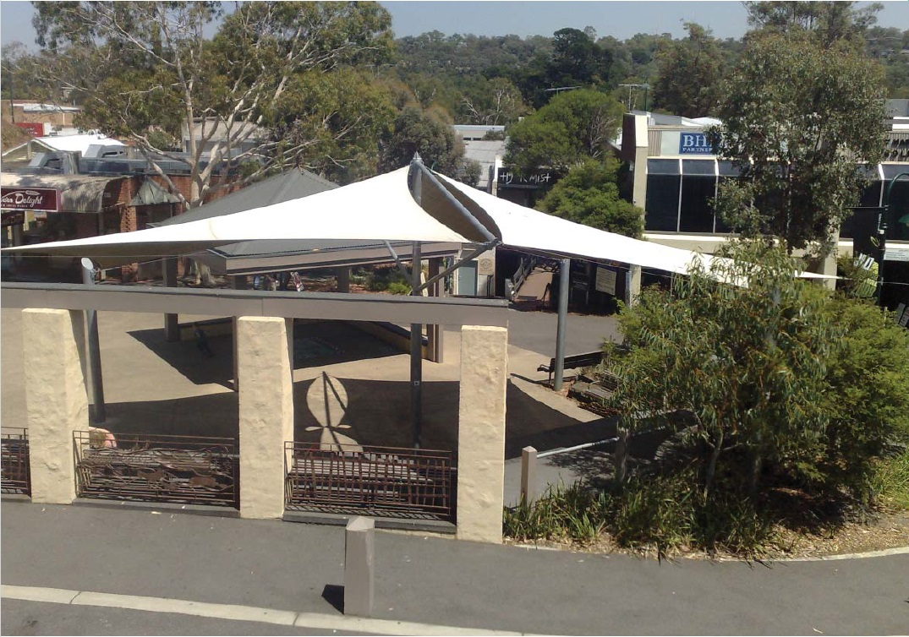

#### PART A – Eltham Town Centre Design Guidelines General

##### 1.1 The Eltham Town Centre

These Design Guidelines have been prepared to guide the future development of land within the Eltham Town Centre (Precincts 1-4 of the Eltham Activity Centre) and build upon the findings and recommendations of the Eltham Major Activity Centre Structure Plan, August 2004. The Design Guidelines affect four key commercial and residential precincts within the Eltham Town Centre consisting of:

Commercial Core

Residential Interface

Transport

Civic Centre

(refer to map)

These Design Guidelines are intended to be used by anyone who is interested or involved in the planning and development process (landowners, designers, developers, community, Council etc) to better understand how to suitably respond to local planning policies and design controls associated with the Eltham Town Centre.

A Design and Development Overlay (DDO6) applies to land within the Eltham Town Centre, which sets regulations and development expectations to realise the preferred character of the area. Use these design guideline documents to assist in the design phases for all new development within the Eltham Town Centre precincts.

The Eltham Town Centre Design Guidelines have been separated into 2 parts and include the following:

**Part A: The General Design Guidelines (applicable to all precincts within the Eltham Town Centre)**

The purpose of the Eltham Town Centre Design Guidelines is to provide basic design directions for all development formats within the Eltham Town Centre boundary including new commercial, residential and community developments.

**Part B: Precinct Design Guidelines (applicable to land located within the specified precinct boundary)**

The purpose of the Precinct Design Guidelines is to provide specific guidance that supports the preferred character for the each precinct.

Note: All new development must have regard to both documents, PART A & B respectively.

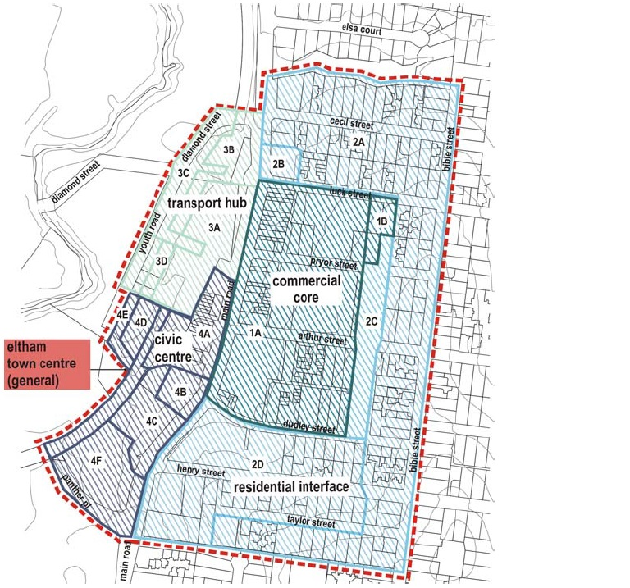

##### 1.2 The Existing Character

Existing Quality and Tones

The following provides a summary and illustration of key existing textural qualities available within the Eltham Town Centre:

* Solid Natural Materials & Finishes
* Earthy & Muted Tones
* Dense Bushland Landscape
* Broad & Full Canopy Trees

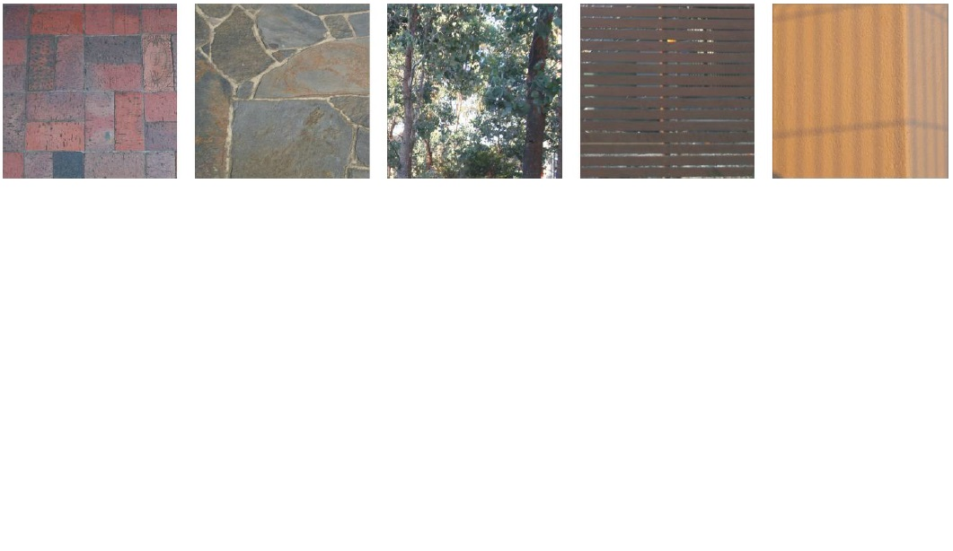

##### Existing Form and Pattern

The following provides a summary and illustration of key typical building and landscape features within the Eltham Town Centre:

* Varied Building Styles & Heights
* Pitched and Angled Roofs Styles
* Simple Building Elements and Clean Lines
* Column Awnings
* Strong Horizontal & Vertical Lines
* Thick & Robust Proportions

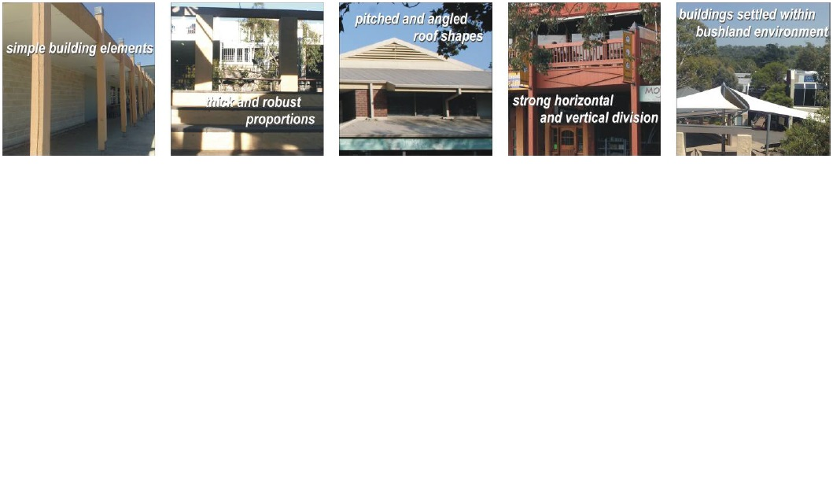

##### 1.3 The Design Guidelines Structure

These design guidelines are intended to ensure that new development provides an appropriate response to the preferred character of the Eltham Town Centre Precincts.

The Eltham Town Centre Design Guidelines are structured around 4 themes including the following:

Site Design (SD): Covers aspects which relate to the existing qualities of the land such as vegetation, topography and land form, streetscape character and pattern and development configuration.

Building Design (BD): Focuses on the design of the building. It provides guidance on the desired scale, building form, appearance, and material treatments.

Building Context (BC): Pays attention to the landscape and access areas around the development. It also provides guidance on ancillary features including signage and lighting.

Public Domain (PD): Provides information on how public places such as streets and civic spaces should be designed to enhance the local character of the area.

Within each theme, a set of objectives, guidelines and design directions provide advice on good design measures that should be considered in all new developments within the Eltham Town Centre.

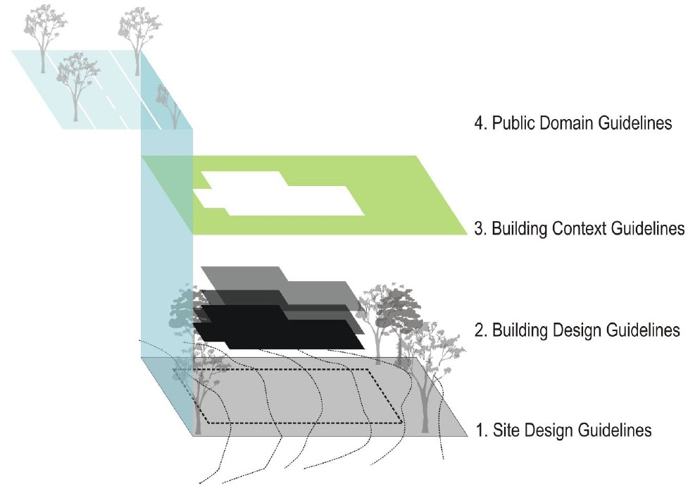

#### PART A – Site Design Guidelines

##### SD01: Site Analysis

**Objective:**

Ensure the building design is site and context responsive.

**Design Guidelines and Directions:**

New applications should provide statements/ detail in regards to:

* Site location, orientation and key views to and from the site
* Proximity to services and open space
* Existing vegetation
* Existing heritage attributes or if abutting any heritage buildings
* Response to the design guidelines

##### SD02: Vegetation

**Objective:**

Protect, retain and enhance significant vegetation and landscape that contributes to the character of the area.

**Design Guidelines and Directions:**

Lots affected by a Significant Landscape Overlay 1 (shown on the planning scheme map as SLO1) must comply with the Landscape Character Objectives and Permit Requirements as stated in the schedule.

When planning, site development to minimise removal of vegetation, particularly established canopy trees.

Avoid damage to environmentally and ecologically sensitive areas.

Apply appropriate protection zones/ buffers around established trees and/ or sensitive areas.

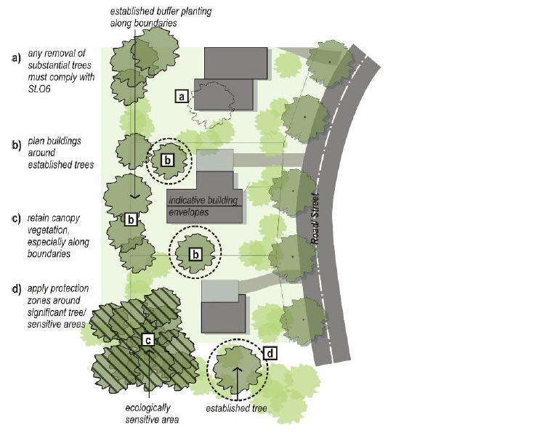

##### SD03: Topography

**Objective:**

Ensure development integrates with the surrounding landscape and minimises disturbance to the natural landform.

**Design Guidelines and Directions:**

Minimise earthworks and visual impact by using split level design on larger sites

Step development to follow contours and the prevailing slope of the land

Site buildings to avoid extensive cut and fill

Access driveways should also follow the contour profile and avoid significant excavation works

Minimise the use and reliance on retaining walls and batter walls. If required, they should appear inconspicuous (no greater than 500mm high) and constructed with natural materials such as stone, timber and textured materials

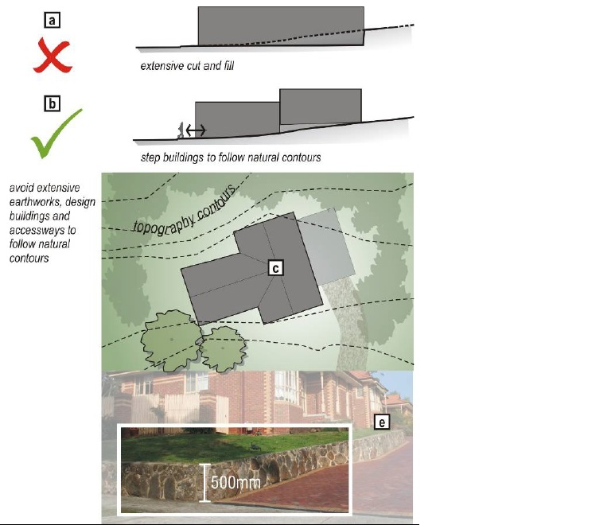

##### SD04: Streetscape Pattern

**Objective:**

Ensure that building setbacks achieve the desired spatial proportion of the street, define the street edge and provide a high amenity for users of the street.

**Design Guidelines and Directions:**

Apply consistent front setbacks with neighbouring buildings.

Development located on street corners should have regard to prevailing setback distances to both streets.

Development on large sites should emulate the subdivision pattern of the streetscape. Incorporate articulated facades with building reliefs to correspond with the prevailing pattern.

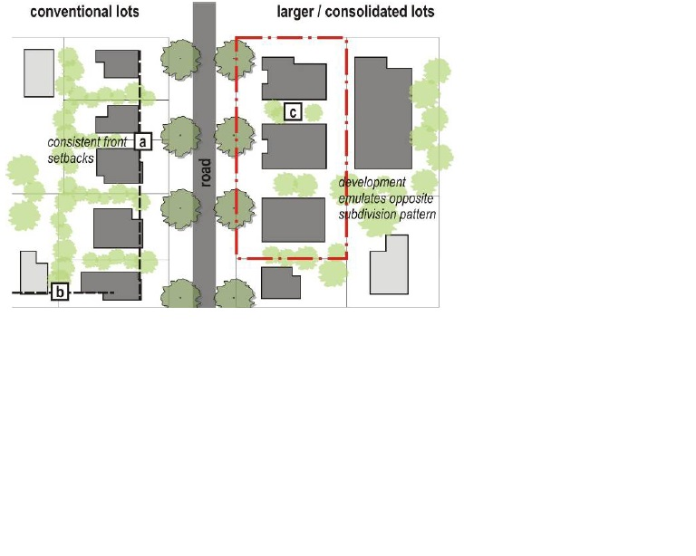

##### SD05: Functionality

**Objective:**

Establish safe, functional, practical developments that contribute to the urban structure of the place.

Ensure that pedestrian routes, streets, footpaths and open spaces interact with and are overlooked by buildings.

**Design Guidelines and Directions:**

Vehicle access points should be separate from pedestrian access points.

Avoid functional impacts on public spaces and pedestrian footpaths.

Entry and exit points should be adequately signed and include sufficient lighting

Street façade and ground floor internal layout should allow visual and physical access to adjoining public realm/street.

If possible and appropriate, establish through pedestrian linkages to connect with key attractions such as open spaces, street networks and public transport

Locate private open spaces/ key active areas to face a northerly and/or easterly direction

New developments with a vertical mix of uses and residential above, should provide equitable and sufficient private open space/ common space for residents.

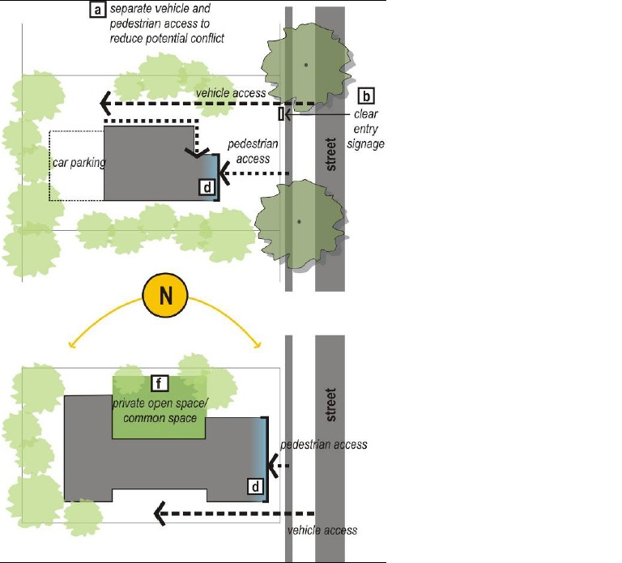

##### SD06: Sustainability

**Objective:**

Establish energy efficient developments that are appropriate to local conditions and climate.

**Design Guidelines and Directions:**

Investigate opportunities for solar heating/ energy harvesting and rain water collections. Locate equipment to be away from public view or be integrated with the building design

Rain water tanks are strongly encouraged to be located to the rear or underground

Position windows to allow for natural cross ventilation

Provide external shading devices to control heat gain

Incorporate extended eaves to allow winter sun and restrict summer sun

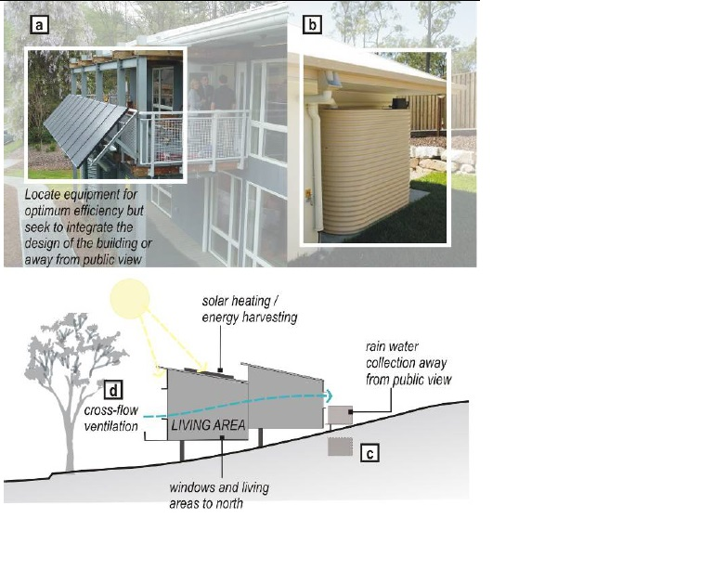

#### PART A – Building Design Guidelines

##### BD01: Building Height and Form

**Objectives:**

Promote building scales consistent with the DDO6 – Eltham Town Centre.

**Design Guidelines and Directions:**

New development must not exceed the mandatory height limits specified in the precinct provisions. Refer to the Nillumbik Planning Scheme and specific precinct design guidelines for further details.

Generally, upper level of developments should be recessive in form and highly articulated.

A landscaped setback of a minimum of 5.5 metres should be provided as shown in the precinct plans.

##### BD02: Building Style and Façade Composition

**Objectives:**

Establish urban development that corresponds to the prevailing built form pattern and rhythm of the streetscape.

Create attractive streetscapes with articulated building frontages suited to the character of Eltham.

**Design Guidelines and Directions:**

New buildings within Eltham Town Centre should draw upon the bushland character of the area. There is a sense of ‘compactness’ as the streets are narrow and the surrounding landscape coverage is dense.

Design building elements such as canopies, balconies, porticos, pergolas, and columns to have a broad and robust profile.

Emphasise an ‘earthy’ appearance through the use of natural and textured materials such as timber, stone and brick.

Façade designs should incorporate horizontal and vertical features such as fenestration, columns, framing etc to correspond with neighbouring buildings within the streetscape.

Architectural elements should be proportionate or correspond to the lot size (i.e. finegrain, conventional, large lots). Break up expansive elevations with architectural features.

Buildings located on corner sites should address both streets and provide ‘multi-sided’ façade treatments. Apply a feature architectural element that ‘wraps’ around the corner of the building.

Buildings should be contemporary in style and use simple building details.

Excessive decoration and historical reproduction styles are strongly discouraged.

Position front entrance to face the primary street.

Facades should incorporate features such as porticos and/or verandahs to visually break up long walls.

Use simple and robust design elements such as modest verandahs with timber colonnades.

Seek to incorporate art to be integrated with the façade design.

Front facades should incorporate treatments that lighten the building form such as glazed balconies, transparent balustrading and fenestration.

Exposed side elevations from the street should incorporate varying material treatments and building articulation.

Service related areas and equipment should be located away from public view or adequately screened.

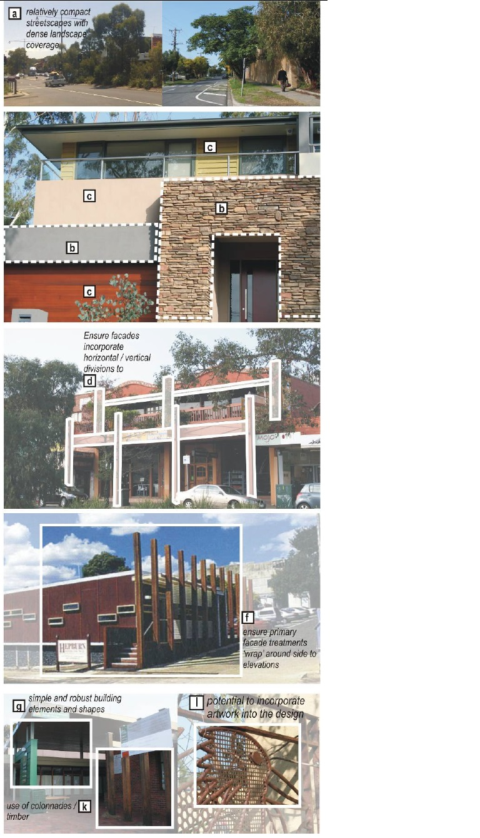

##### BD03: Roof Form

**Objective:**

Promote roof styles that are respectful to the existing buildings within the area and establish a consistent ‘roofscape’ image

**Design Guidelines and Directions:**

Incorporate roofs pitched, gabled or hipped greater than 10%.

Avoid excessive use of flat, curved or high pitch roof forms.

Apply extended eaves or roof cap (of at least 450mm in depth) to the roof design. This will enhance the presentation of the building and assist in controlling sun light penetration.

Roof material should be matte in finish and avoid surfaces that are highly reflective material such metal panels

Service related areas and equipment should be located away from public view or screened appropriately through integrated architectural or landscape treatments.

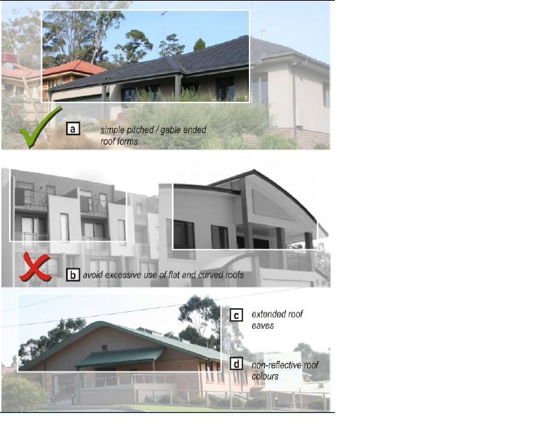

##### BD04: Materials, Colours, Hues and Texture

**Objective:**

Encourage a diverse range of material usage that complement the urban and landscape setting of Eltham.

**Design Guidelines and Directions:**

Primary base colours should be muted and subdued in tone.

Accent colours are encouraged but should be used strategically for key building façade features.

Use a mixture of contemporary and traditional natural materials, textures and finishes including lightweight cladding, timber, render, non masonry sheeting, glazing, stone, brick, mud-brick and iron roofing.

Façades and elevations should incorporate a complementary material palette that demonstrates diversity in textures.

Avoid large expanses of uninterrupted walls of a singular surface treatment.

Walls detailed with natural stone and masonry such as brickwork (including rendered), rammed earth or mud brick will create an appearance of mass and weight. Such wall treatments should be offset with features that offer a light weight appearance such as verandahs, pergolas, and balanced areas of glazing.

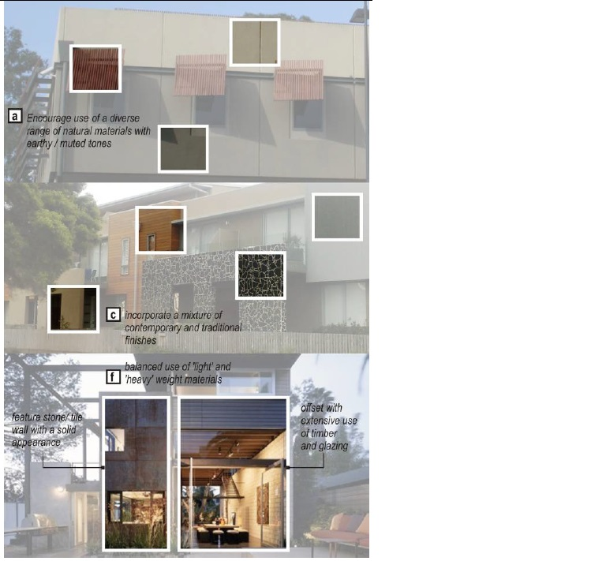

#### PART A – Building Context Guidelines

##### BC01: Access and Parking

**Objectives:**

Ensure the design of parking and access areas is safe, practical and attractive.

**Design Guidelines and Directions:**

The number of vehicle crossovers should be limited to 1 on standard sized lots. On larger sites and consolidated lots, rationalise the number of vehicle entry points. On a corner site, locate the vehicle entry point to be accessed from the side street.

Where possible locate entry points from laneways or secondary street frontages

Avoid locating car parking in front of the building. Position parking areas to the sides or rear of the building combined with extensive screen landscaping.

Basement car parks should be naturally ventilated. Incorporate screening devices such as perforated sheeting, timber screens and/or landscaping to conceal exposed views to car parking areas.

Plant indigenous canopy trees to provide shade and screen car parking areas.

Incorporate a clear and legible pedestrian footpath network in open car parking areas. Footpaths should be a minimum 1.5m wide to allow for comfortable pedestrian traffic.

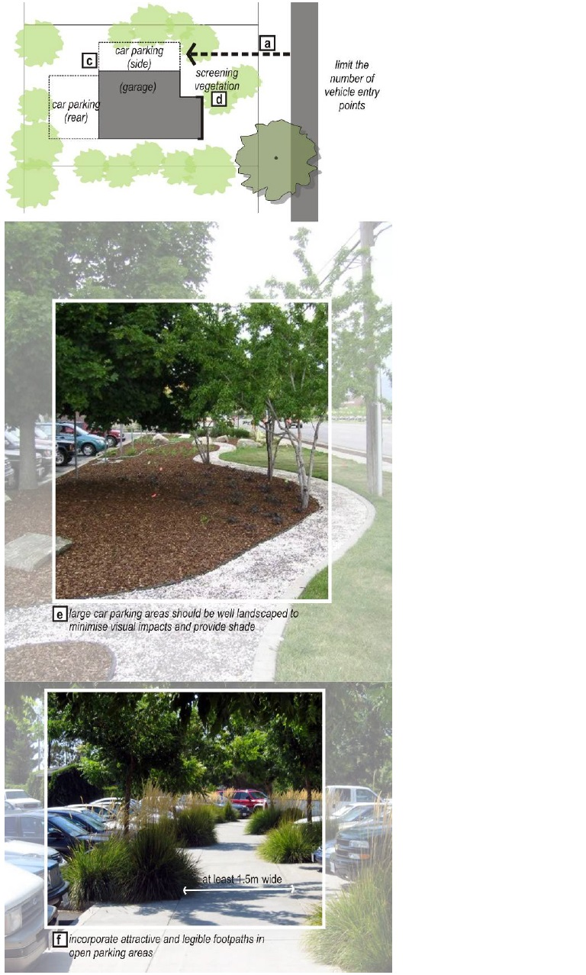

##### BC02: Boundary Treatments - Landscape and Fencing

**Objective:**

Ensure that development sites with front, side or rear setbacks are extensively landscaped with indigenous vegetation so as to contribute to the Eltham form and character.

Encourage front fences that offer a sense of openness from the street.

**Design Guidelines and Directions:**

Vegetation selection is of native or indigenous species.

Residential development should include at least 2 canopy trees on site.

Apply a ‘layered’ landscaping regime which incorporates canopy trees, shrub planting and low lying plants.

Seek to define the front boundary through landscaping treatments and edge planting.

Front fencing is discouraged. But if required, they should be:

* Low in height (maximum of 1.2m);
* Visually transparent (which incorporates regular spacing between pickets and rails); and
* Constructed with light weight materials, such as timber and steel.
* Side fences should not begin in front of the main building façade.
* Side, rear or screen fences should not exceed 1.8m in height.
* For retaining walls design, refer to guidelines SD04 – Topography.

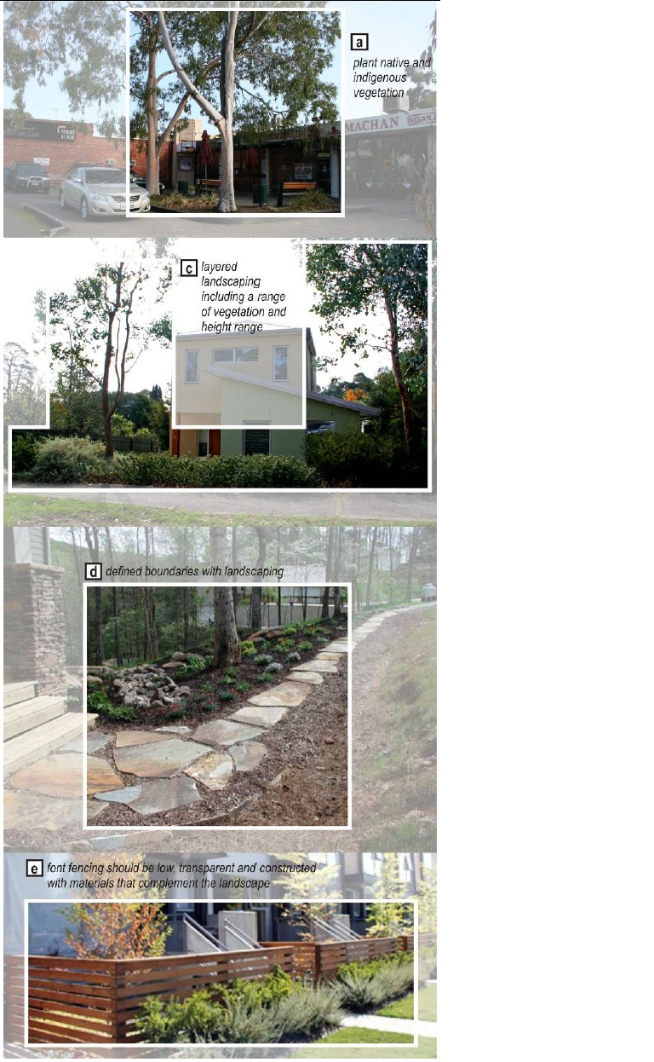

##### BC03: Signage and Lighting

**Objective:**

Encourage signage that is integrated into the design of the building façade, surrounding streetscape and landscape setting.

Ensure signage and lighting is not dominating elements within the streetscape.

**Design Guidelines and Directions:**

Signage is not encouraged on lots within the Residential Growth Zone.

Integrate signage and lighting with the building form. Signage should be located below the roof eave.

The size, height and proportion of signage should be complementary to the building and not a dominating element.

Generally, signage should not exceed 10% of the entire façade or clearly demonstrate that it ‘fits’ with the style of the building.

Consolidate signs for mixed use and commercial developments to avoid the visual clutter of signage and displays.

Signage should not be painted/ fixed on the windows of the building.

Road side signage should be avoided.

Signage should not be located on the roof or exceed the parapet height of the building.

Avoid the use of animated signs or coloured neon lighting.

Lights and equipment should be simple in style and discrete in profile.

Light spillage from signage and lighting for car parks should be contained to within property lines. Landscaping should not be relied upon to prevent light spillage into the public realm.

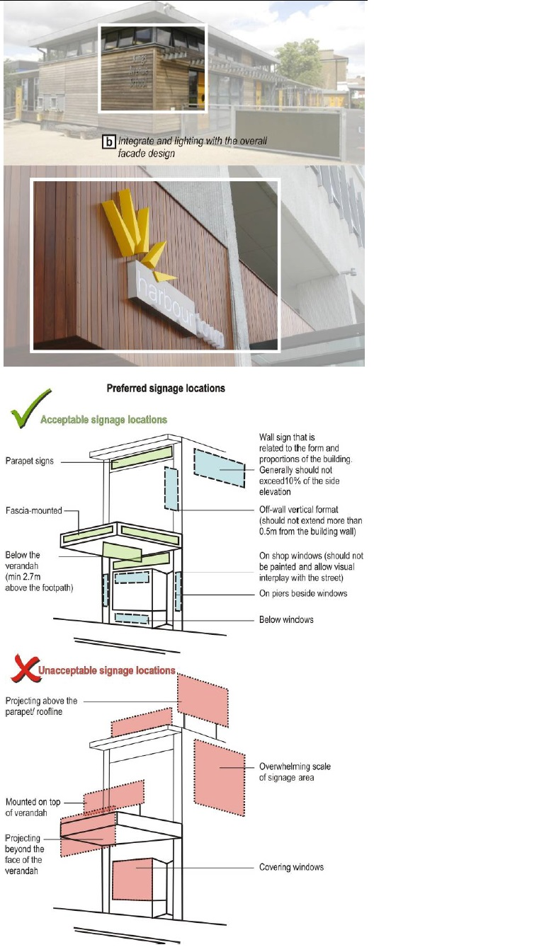

#### PART A – Public Domain Guidelines

##### PD01: Access, Footpaths and Parking

**Objectives:**

Enhance access to public transport services.

**Design Guidelines and Directions:**

Avoid removal of existing canopy trees when locating new vehicle crossovers.

Provide direct and logical pedestrian links to key public transport facilities (Eltham Train Station and Bus interchange). These pathways should incorporate adequate signage and way finding techniques (such as special pavement treatments).

Continue feature paving along Main Street (random stone paving or provide similar treatment) at key pedestrian spaces within the Civic Centre, Commercial Core and Transport Precincts. Establish a common paving theme within these Eltham Town Centre areas.

Design pedestrian spaces to be clearly separated with vehicle routes and employ traffic calming devices (such as bollards, rumble paving etc.).

Shared bicycle and pedestrian paths should be a minimum of 2.5 metres in width, clearly marked and preferably constructed with asphalt or finished concrete.

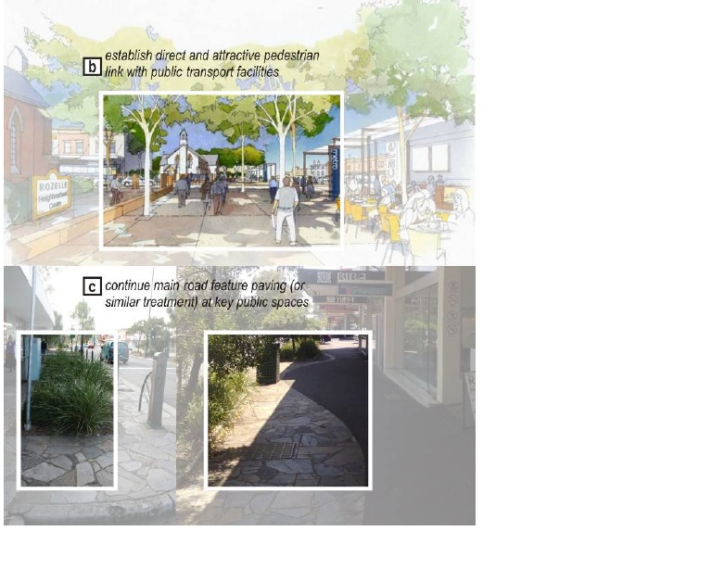

##### PD02: Landscape – Soft and Hard

**Objective:**

Protect and enhance significant street tree avenue planting that contribute to the streetscape character of Main Road and connecting streets.

Create a lively and people-based Eltham Town Centre which reflects the artistic and cultural aspirations of the community.

**Design Guidelines and Directions:**

Establish landscaped gateway features at entry points toward the Town Centre (north and south of Main Road).

Retain established native vegetation within all streets that contributes to the ‘green and leafy’ appearance of the area.

Planting of new street trees should be generally no more than 10-15 metres apart.

Plant low-lying shrubs and canopy trees to minimise the visual impact of roadside parking.

Reinforce a consistent native bush themed avenue planting with a common selection of species available in the area.

At key civic spaces, allow for prominent areas for public art to be established.

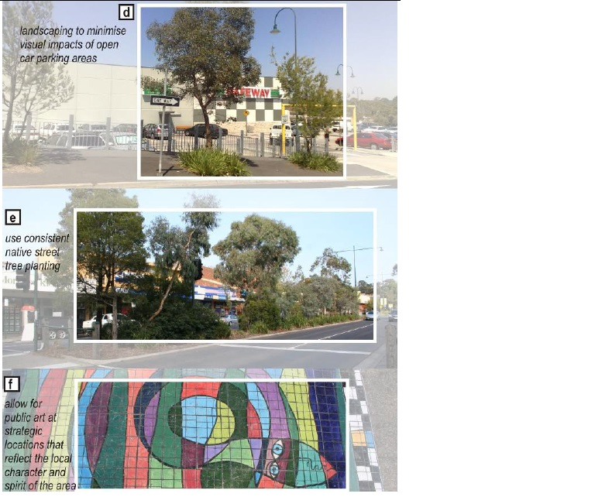

##### PD03: Street Furniture, Lighting and Signage

**Objective:**

Ensure the signage, lighting and street infrastructure do not dominate the streetscape and visual clutter is minimised.

**Design Guidelines and Directions:**

Seek to progressively upgrade bus stops and street furniture such as bins, seating and shelters to be consistent in design and appearance.

Utilise textured materials such a timber and stone to reflect an earthy quality that blends with the surrounding landscape.

Street furniture should be designed to offer a robust and ‘bulky’ appearance. Design furniture with thick proportions and utilise natural materials such as timber and stone.

Lights should be simple in appearance. Mock heritage of past eras such as Victorian styling with ornate features should be avoided.

New signage should be contemporary and incorporate materials familiar to the area such as timber, steel and stone.

Public signage should be compatible in design, scale, material, style, and colour with the existing bushland qualities and with the overall streetscape.

Where possible, progressively reduce kerbside infrastructure to minimise visual clutter. Limit the quantity of ‘A’ frame signage along key pedestrian routes and shared ways.

