Nillumbik Shire Council

Disability Action Plan

2020-2024

Easy English

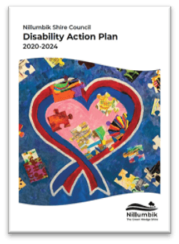About this book

This book is about our Disability Action Plan.

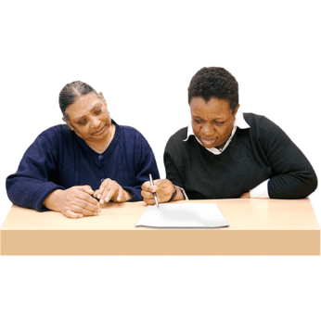It is written in a way that is easy to read.

You can ask someone to help you read this book.

Some words are in **blue**. You can find the meaning of these words at the end of the book. Go to page 24.



**Blue Words**

What is in this book

|  |  |
| --- | --- |
| **What is a Disability Action Plan?** | **3** |
| **Why we need a Disability Action Plan** | **4** |
| **How we made the Disability Action Plan** | **6** |
| **What you want us to do** | **8** |
| **What we are going to do** | **9** |
| **Actions to make it easier for people to use our buildings and services** | **10** |
| **Actions to make it easier for people to get a job** | **14** |
| **Actions to help people to be included in the community** | **17** |
| **Actions that help stop discrimination in our community** | **21** |
| **How to find out more** | **23** |
| **What the blue words mean** | **24** |

What is a Disability Action Plan?

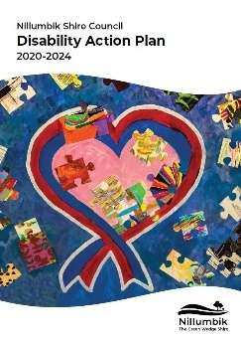

Our Disability Action Plan says what we will do to make it easier for people with disability to

* use our buildings and services
* use services and programs
* get the information they need
* get a job

 and

* do community activities.

Why we need a Disability Action Plan

Lots of people who live in Nillumbik have a disability.

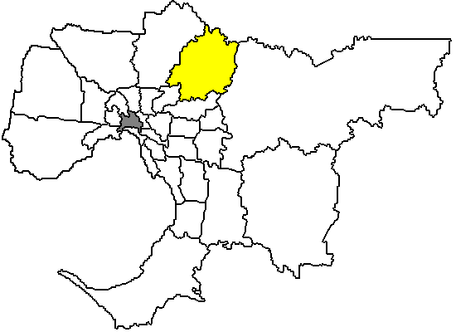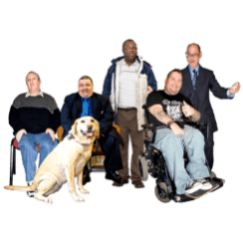

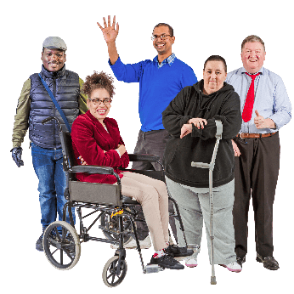

People with disability should feel included in our community.

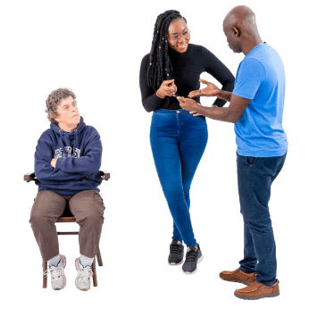Sometimes people with disability are treated worse than other people. This is called **discrimination**.

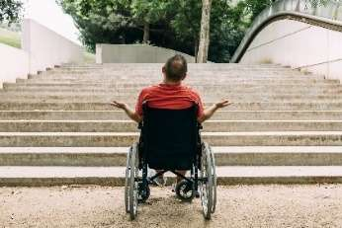

Discrimination can happen for lots of reasons. For example because you

* have a disability
* 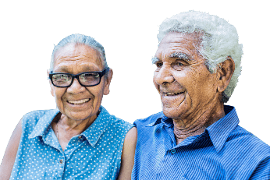are a younger or older person
* are part of the **indigenous community**
* come from a different background or country
* are part of the **LGBTI** **community**.



Discrimination is not OK.

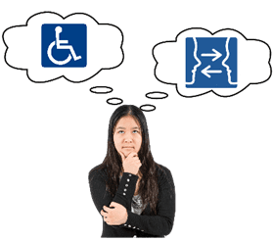

Our Disability Action Plan will also help to change the way people think about disability.

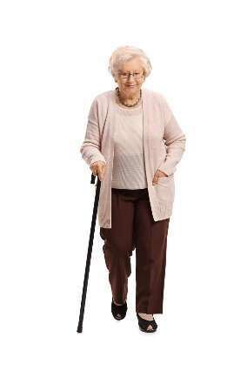

Our Disability Action Plan can help others in the community too. For example

* older people
* 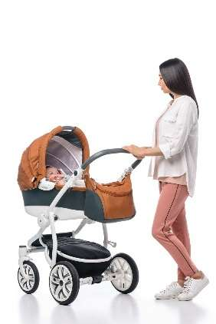carers
* carers with prams
* people who have been hurt or who are sick for a short time.

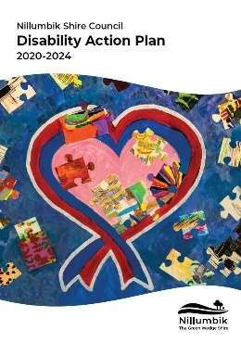It is part of our job to make a Disability Action

Plan.

How we made the plan

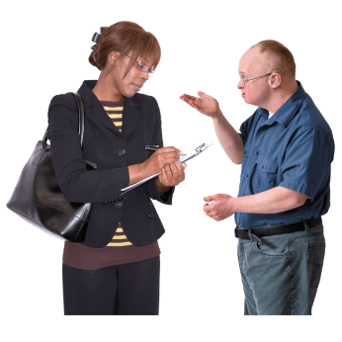We asked lots of people to tell us what we can do to make things better for people with disability.

We asked

* people in the community
* 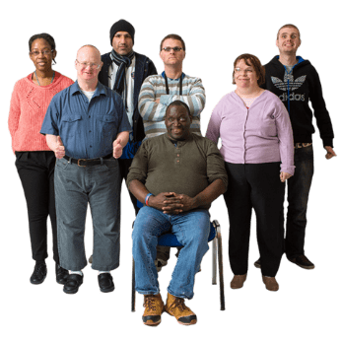our staff
* **service providers**
* support workers
* disability groups
* and more.

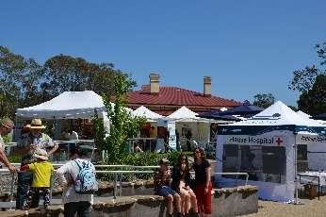We spoke to people at different places. For example at

* **events** and **festivals**
* libraries
* 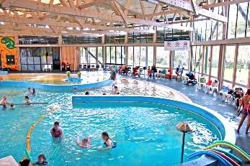disability services
* places where people do exercise.

For example gyms and swimming pools.

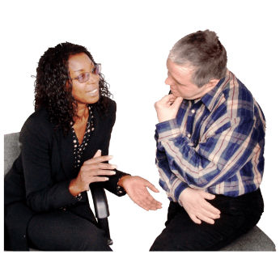

We asked people to tell us what they think in different ways. For example

* 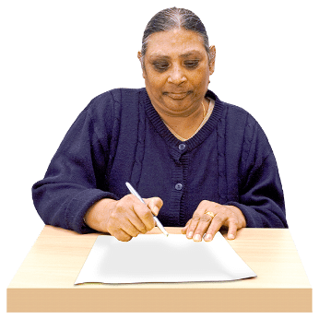talking face to face
* **surveys**
* feedback cards
* **workshops**.

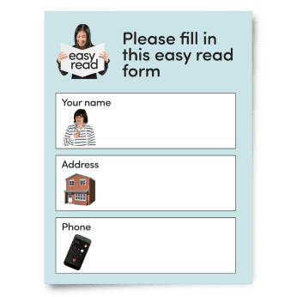

We also did a **survey** in Easy English. This was so people with **intellectual disability** would be included too.



More than 330 people helped us make the plan.

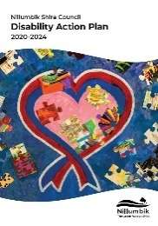

We used all the information to make our plan.

What you want us to do

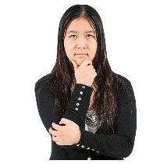

The people we spoke to said we need to

* help others understand disability.

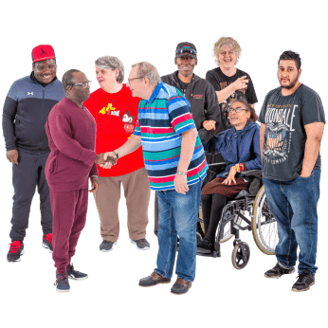

* have more support groups so people with disability can meet people and do activities.

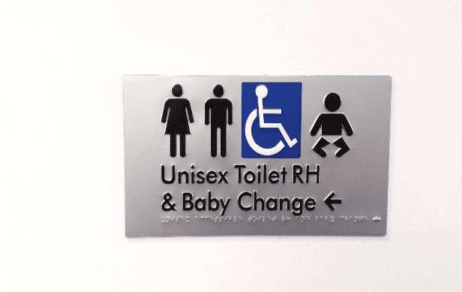

* make sure our information and signs are **accessible.**
* 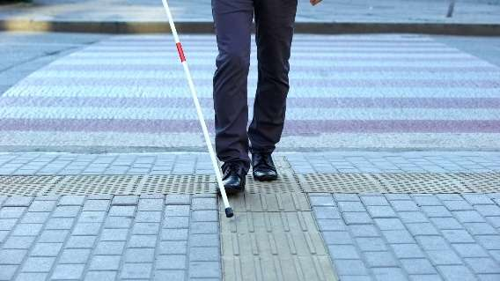make it easier for people with disability to get around. For example make more accessible
  + footpaths
  + 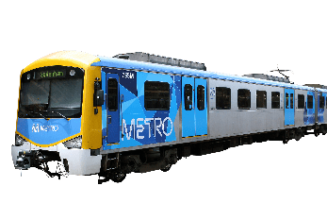parking
  + transport
  + shops and businesses
  + 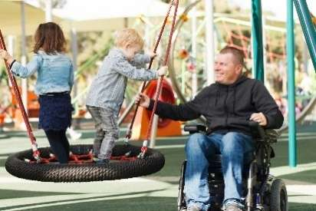places where people exercise
  + **trails** and **play spaces.**

What we are going to do

The most important things people said we need to do are

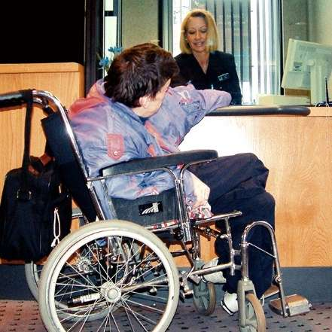

* make it easier for people with disability to use our buildings and services.
* make it easier for people with disability to find information about services, training, jobs and things to do in Nillumbik. 

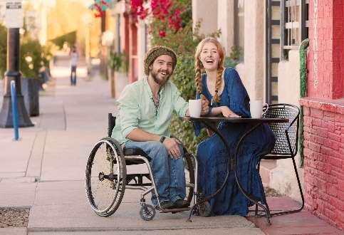

* help people with disability to be included in the community.



* help stop **discrimination** in our community.

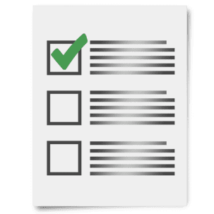

We have made a list of how we will do these things. These are called **actions**.

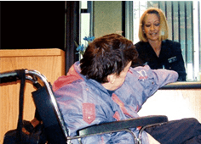Actions to **make it easier for people to use our buildings, places and services**

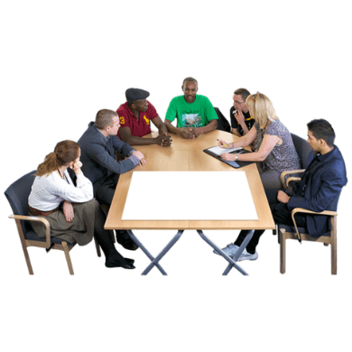

We will

* work with others to get more places for people with disability to live in Nillumbik.
* think about how we can make more places for people with disability to live in our area. We will think about

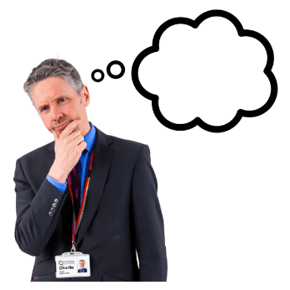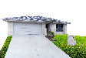

* + different sorts of housing
  + good areas for housing
  + housing for older people.
* give training to our staff who work in buildings and **recreation**. The training will be about how to make places and services easier for people with disability to use.

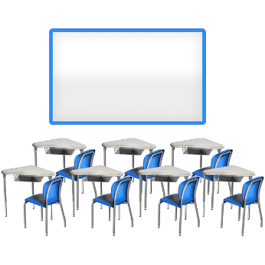

We will

* 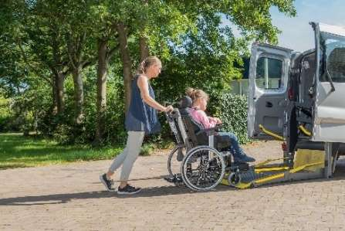work with others to get more transport for people with disability.
* 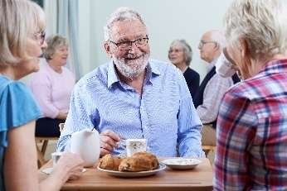work with others to include people with disability in activities that are now only for older people who live in Nillumbik.

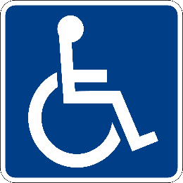

**ONLY**

* work on more **accessible** parking in Nillumbik.
* 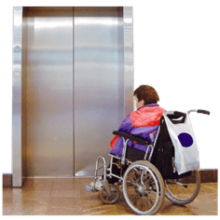stop people who should not be using accessible parking areas from using them.
* try to make it easier for people with disability to get in and out of Council buildings.
* 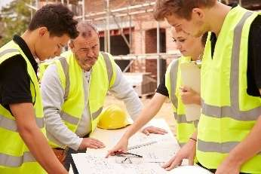make sure we think about **accessibility** whenever we are planning buildings, places and services in Nillumbik.

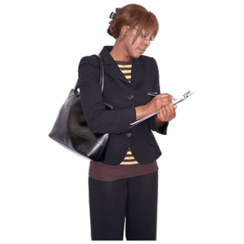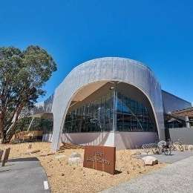

We will

* ask people who know a lot about **accessibility** to check our new buildings and places. They will check to make sure they are easy for people with disability to use.

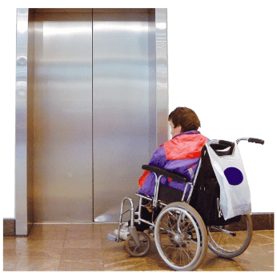

* try to make all our buildings and places more **accessible**. We will talk to people with disability about how we can do this.



* make sure our staff have training about how to make our information and **documents** accessible.
* help make information more accessible. For example



* + information about our services and how to use them.

We will

* 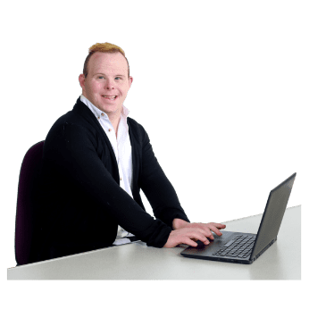make sure our services like
  + email
  + phones
  + website

are more **accessible**.

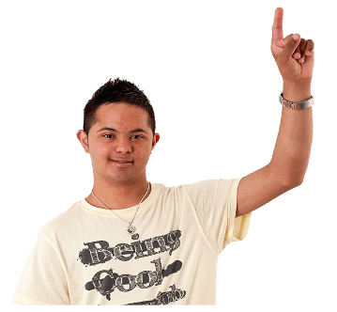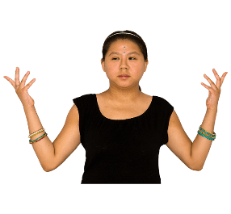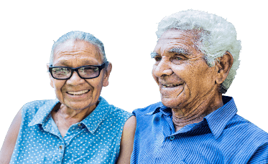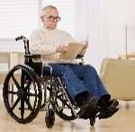

* make sure we include photos of
  + people from different backgrounds
  + people with disability

in our **documents** and website.

* work with others so people with disability have information about



* + how to get ready for an **emergency**
  + what to do in an emergency**.**

Actions to make it easier for people to get a job

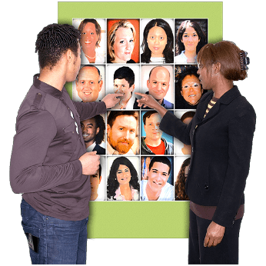We will

* make it is easier for people with disability to find information about jobs at Nillumbik Shire Council.
* 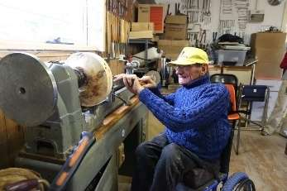tell people that Nillumbik Shire Council is a good place for people with disability to work.
* work with businesses to make it easier for people with disability to get a job.

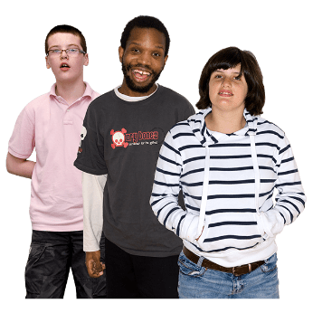

* 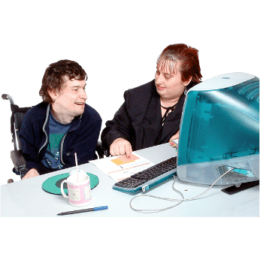work with high schools to make a **work experience** program for young people with disability.
* make a new **work experience** program for adults with disability.

We will



* 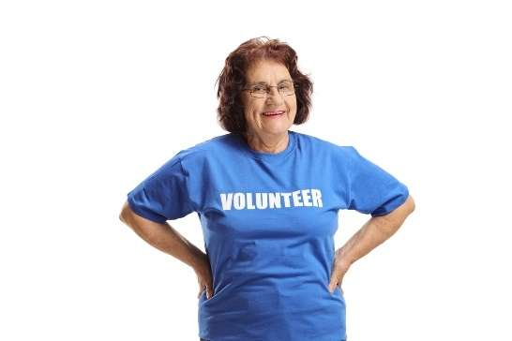give training to our staff who give people jobs so they understand what people with disability need.
* make it easier for people with disability to **volunteer** in council activities.
* 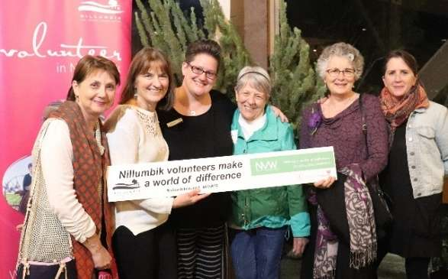make sure we talk about our
  + **volunteers** with disability
  + programs that include people with disability

at our special **volunteer event** that happens each year.

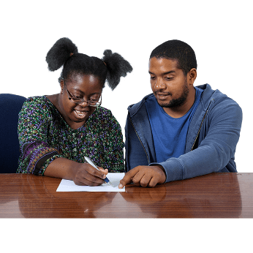

* work with the **Brotherhood of St Laurence** to help people with disability in Nillumbik
  + get new skills
  + have more social activities.

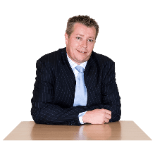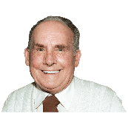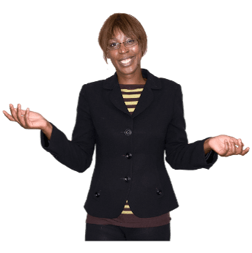

We will

* 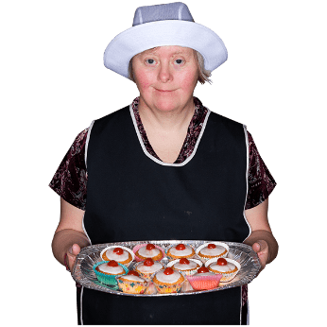ask staff to think about using a business that **employs** people with disability. For example when they need food for a Council **event** or meeting.

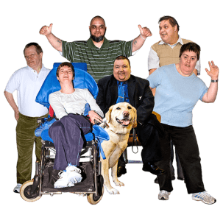

Actions to help people to be included in the community

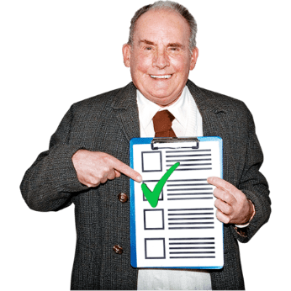

We will

* make a special guide for staff to help people make events more accessible and inclusive.



* help make a list of community groups and services in our area.
* tell people about International Day of People with Disability Grants. This is money the Council gives for events to celebrate International Day of People with Disability.

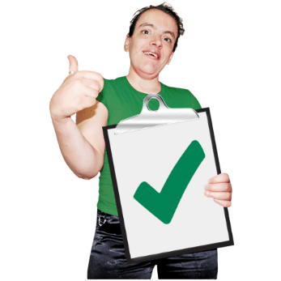

* help disability groups to apply for Council **grants.**

We will

* 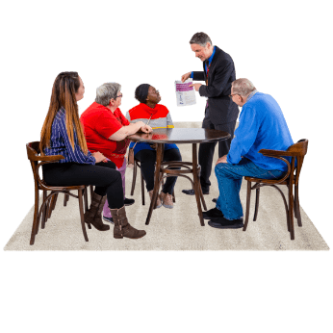support local disability groups and services wherever we can. Tell others about the great work they do.
* look for ways to make it easier for
  + people with disability
  + carers
  + families

to tell us what they think.

* use our **Inclusion Newsletter** to tell people with disability about

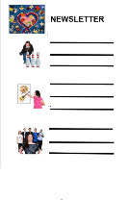

* + local **events** and programs
  + 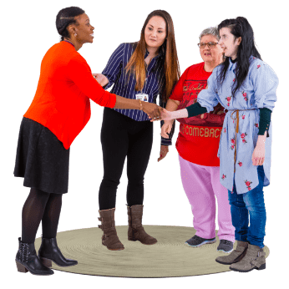other things that would be good for them to know.
* try to get more people to join the **Nillumbik Inclusion Network**.

We will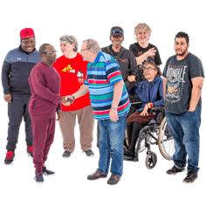

* work with others to make more activities where

people with disability can meet new people.

* work with our Positive Ageing Officer to

tell people about support groups for carers in Nillumbik.

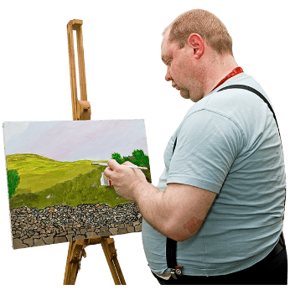

* help local artists with disability to be part of arts programs across Nillumbik.

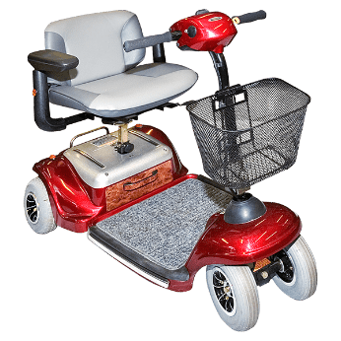

* ask local businesses to help people charge electric wheelchair or **mobility scooter** batteries.

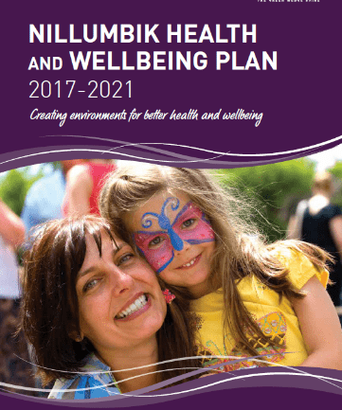

* make sure we think about what people with disability need when we make our new **Health and Wellbeing Plan**. This is so everyone who lives in Nillumbik can live a healthier life.

We will

* 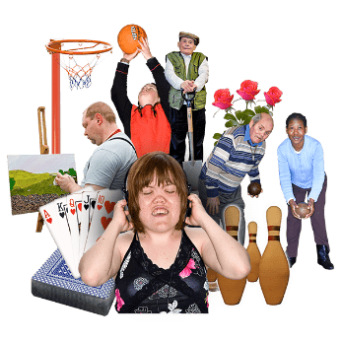make it easier for people with disability to be included in **recreation** activities in Nillumbik.
* make more **sensory friendly** activities around Nillumbik.

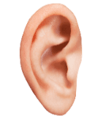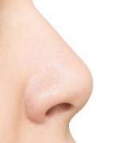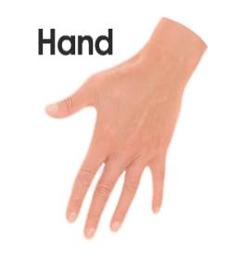

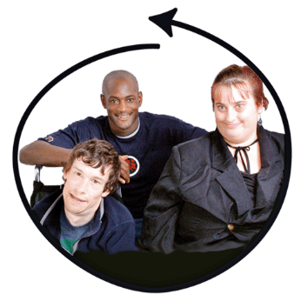Actions that help stop discrimination in our community

* We will give our staff more training and information about disability. Support our staff to be more **inclusive** of people with disability.



* 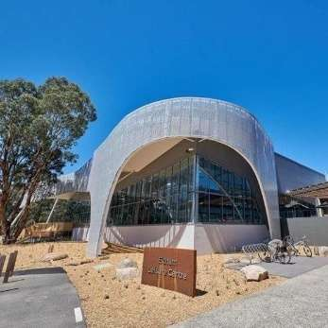make sure that the company we use to run our **leisure centres** has a Disability Action Plan. This will make sure these leisure centres can better support people with disability.
* 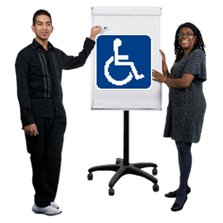help local businesses to be more welcoming of people with disability.

We will

* give training to our staff to help them understand
  + 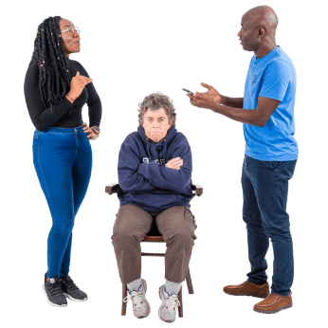that they may be **excluding** people with disability without meaning to

and

* + what they can do to fix this.
* give training to staff about
  + **Human Rights**
  + treating everyone the same
  + how it is everyone’s job to stop **discrimination** and **sexual harassment**.
* 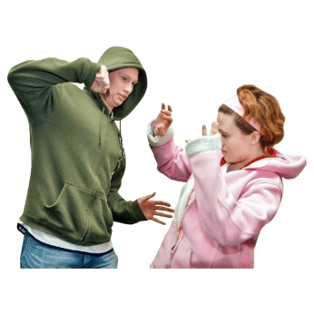do a workshop every year about how to stop **violence** against women. The workshop will talk about violence against women with disabilities.

How to find out more

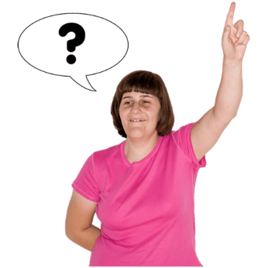

You can ask questions about the Disability Action Plan. You can ask someone from our Community Inclusion team.

**Phone** 9433 3111

**Email** [inclusion@nillumbik.vic.gov.au](mailto:inclusion@nillumbik.vic.gov.au)

If you have a **hearing impairment** or **speech impairment** you can contact the National Relay Service and ask for the Community Inclusion team.

**Phone** 1300 555 727 if you use a regular handset but sometimes find it hard for others to understand you.

**Phone** 133 677 if you are a TTY user.

**Internet** [www.relayservice.com.au](http://www.relayservice.com.au).

What the blue words mean

|  |  |
| --- | --- |
| **accessible** | Easy to use or understand for everyone. |
| **accessibility** | How easy to use or understand something is for everyone. |
| **background** | The culture or place you come from. |
| **Braille** | A special way of writing for people who are blind or find it hard to see. You can use your fingers to read the words. |
| **Brotherhood of St Laurence** | A service provider that supports people with disability. |
| **business**  **businesses** | A place where people work and earn money. For example   * a shop * a service   an office. |
| **document** | Paper or papers with information on them. These can be actual pieces of paper or on a computer. |

|  |  |
| --- | --- |
| **discrimination** | Discrimination is when you are  treated differently because you   * have a disability   or   * are not included   because you have a disability. |
| **emergency** | When something happens that puts you in danger.  For example  a medical emergency is when you need a doctor immediately or else you might get very sick or die. |
| **employs** | To give someone a job. |
| **event** | Something that happens or takes place. For example   * a party * a community activity. |
| **excluding** | To make another person feel left out or not included. |
| **festival** | An event where lots of people to come to celebrate. |
| **grants** | Money that governments offer for businesses or community groups to do special work. For example  There are grants for groups to run disability programs or do activities that help people with disability. |
| **Health & Wellbeing Plan** | Our plan about how we will help people in Nillumbik to be more healthy. |
| **hearing impairment** | When a person finds it hard to hear or cannot hear at all. |
| **hoist** | A piece of equipment on the ceiling that can be used to life or move a person. |
| **Human Rights** | Everyone’s right to   * be treated with respect * be treated fairly * have the basic things they need to live. |
| **inclusive**  **inclusion** | When everyone can join in. Nobody is left out. |

|  |  |
| --- | --- |
| **Inclusion Newsletter** | A newsletter about inclusion in Nillumbik. It has information about   * news * events * programs   happening in Nillumbik that include people with disability. |
| **indigenous communities** | People related to the first Australians. First Australians are people who lived in Australia before others came from overseas to live here.  Indigenous people are also called   * Aboriginal   and   * Torres Strait Islanders. |
| **intellectual disability** | When someone finds it harder to   * understand and learn new things * communicate * take care of themselves * talk to others. |
| **LGBTI** | A group of people who have all different sexual preferences and identities. For example   * Lesbian * Gay * and more. |
| **leisure centre** | A place where people can exercise and have fun. They usually have a   * swimming pool * gym. |
| **mobility scooter** | A bike with an engine which can be easier for people with disability to use. |
| **Nillumbik Inclusion Network** | A group of people with disability who meet to talk about what can be done to make life better for people with disability in Nillumbik. |
| **play space** | Areas where people play. For example   * sports courts * playgrounds. |
| **Positive Ageing Officer** | A person whose job is to find ways to make life better for older people in Nillumbik. |
| **recreation** | Activities people do for fun and exercise. |
| **sensory friendly** | A place or experience that is good for people who may not like   * loud noises * the way some things smell, feel or taste. |
| **service provider** | An organisation that supports people with disability. |
| **sexual harassment** | When someone   * touches you   or   * talks to you about sex or your body   in a way that you do not like or want. |
| **speech impairment** | When a person finds it hard to speak or cannot speak at all. |
| **survey** | To ask people to answer some questions about what they think about something. |
| **trail** | Walking paths. These may be in bushland, parks and other outdoor areas. |
| **violence** | Doing something that hurts another person or a group of people |
| **volunteer** | To do work without being paid. |
| **work experience** | When you can learn about a job by actually doing it. Someone teaches you about the job and helps you try it out. |
| **workshop** | To get a group of people together to   * talk about a subject or problem * work on a skill. |

**You can contact us at**

**Our office** Nillumbik Shire Council

Civic Drive

Greensborough VIC 3088

**Phone** 9433 3111

**Email** inclusion@nillumbik.vic.gov.au

The Easy English in this book is written by Clear Words. [www.clearwords.com.au](http://www.clearwords.com.au)

Images in this book are from

Photosymbols. [www.photosymbols.com](http://www.photosymbols.com)

IStock. [www.istock.com](http://www.istock.com)

Google Free Images

You can print this book. If you want to copy or use images from this book you must ask us first.